**REST Home Task**

1. **Verify the number of resources at each resource end point:**

Total 6 Resources

1. Post: 100 Resources

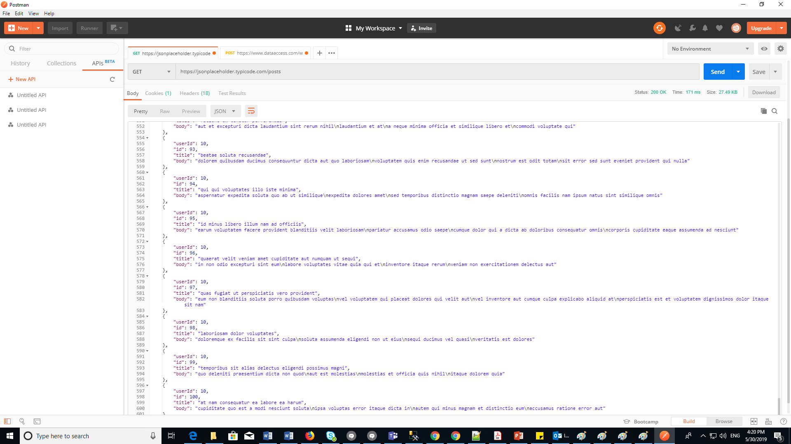

1. Comments: 500 Resources

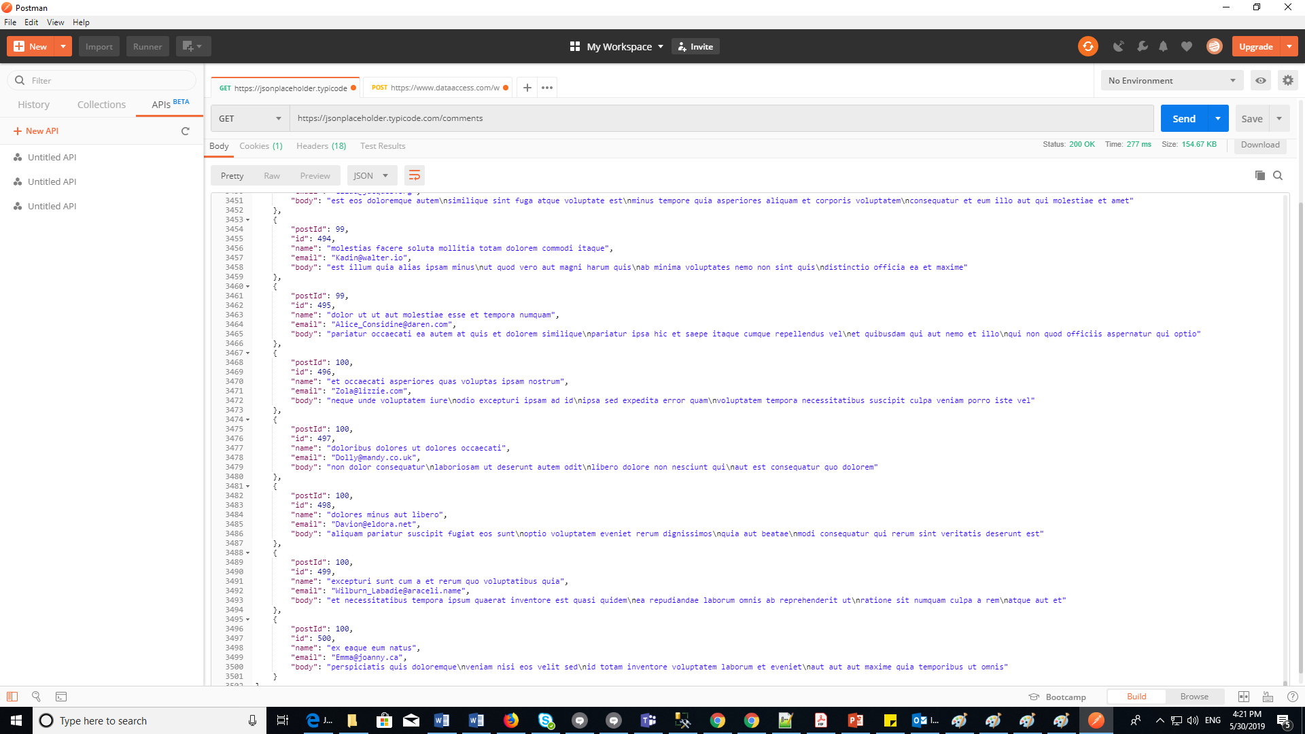

1. Albums: 100 Resources

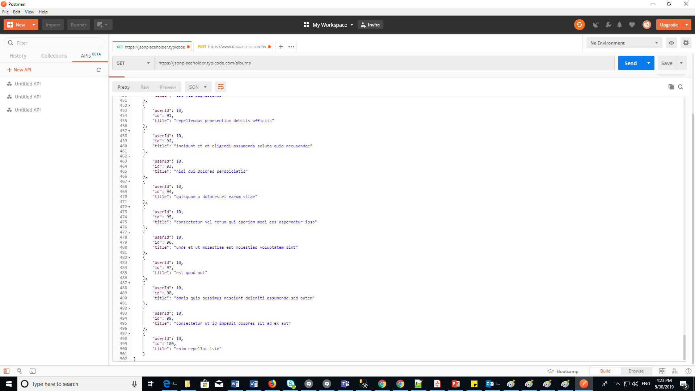

1. Photos: 5000 Resources

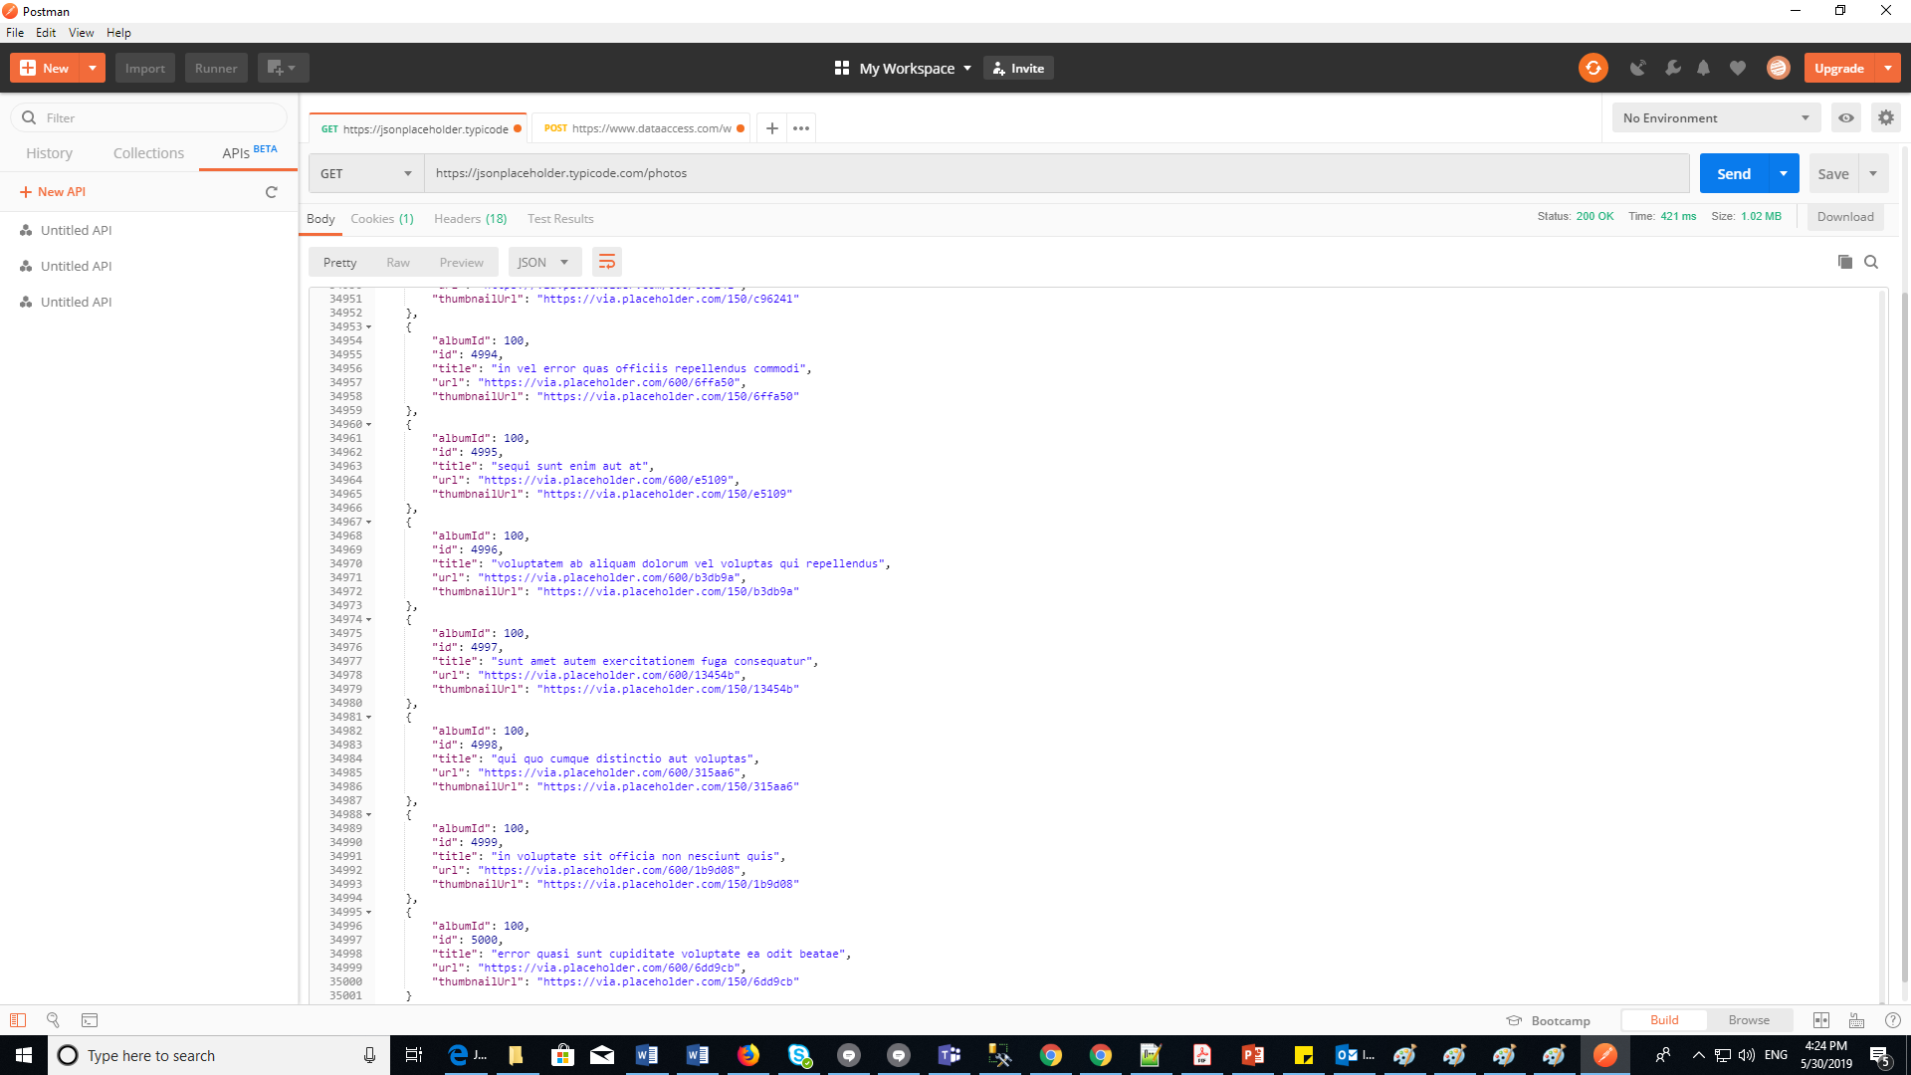

1. Todos: 200 Resources

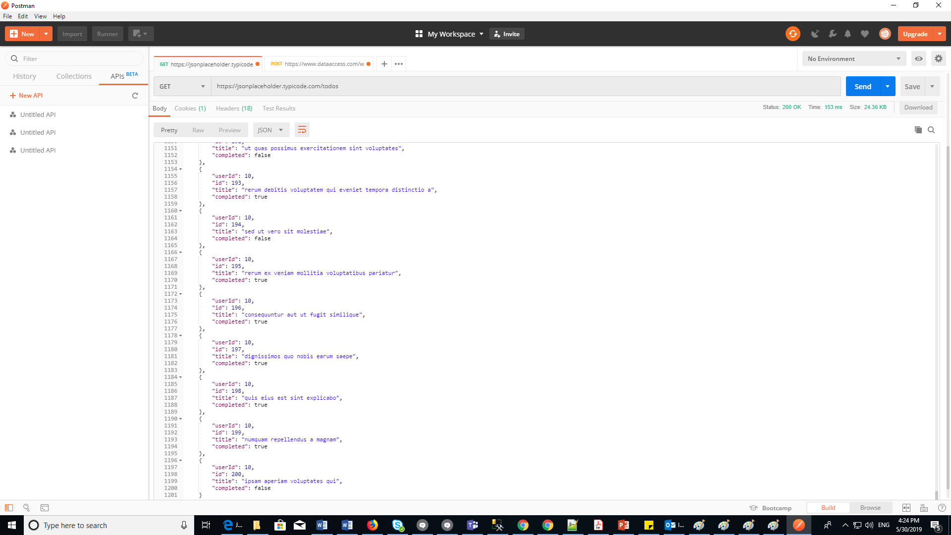

1. Users: 10 Resources

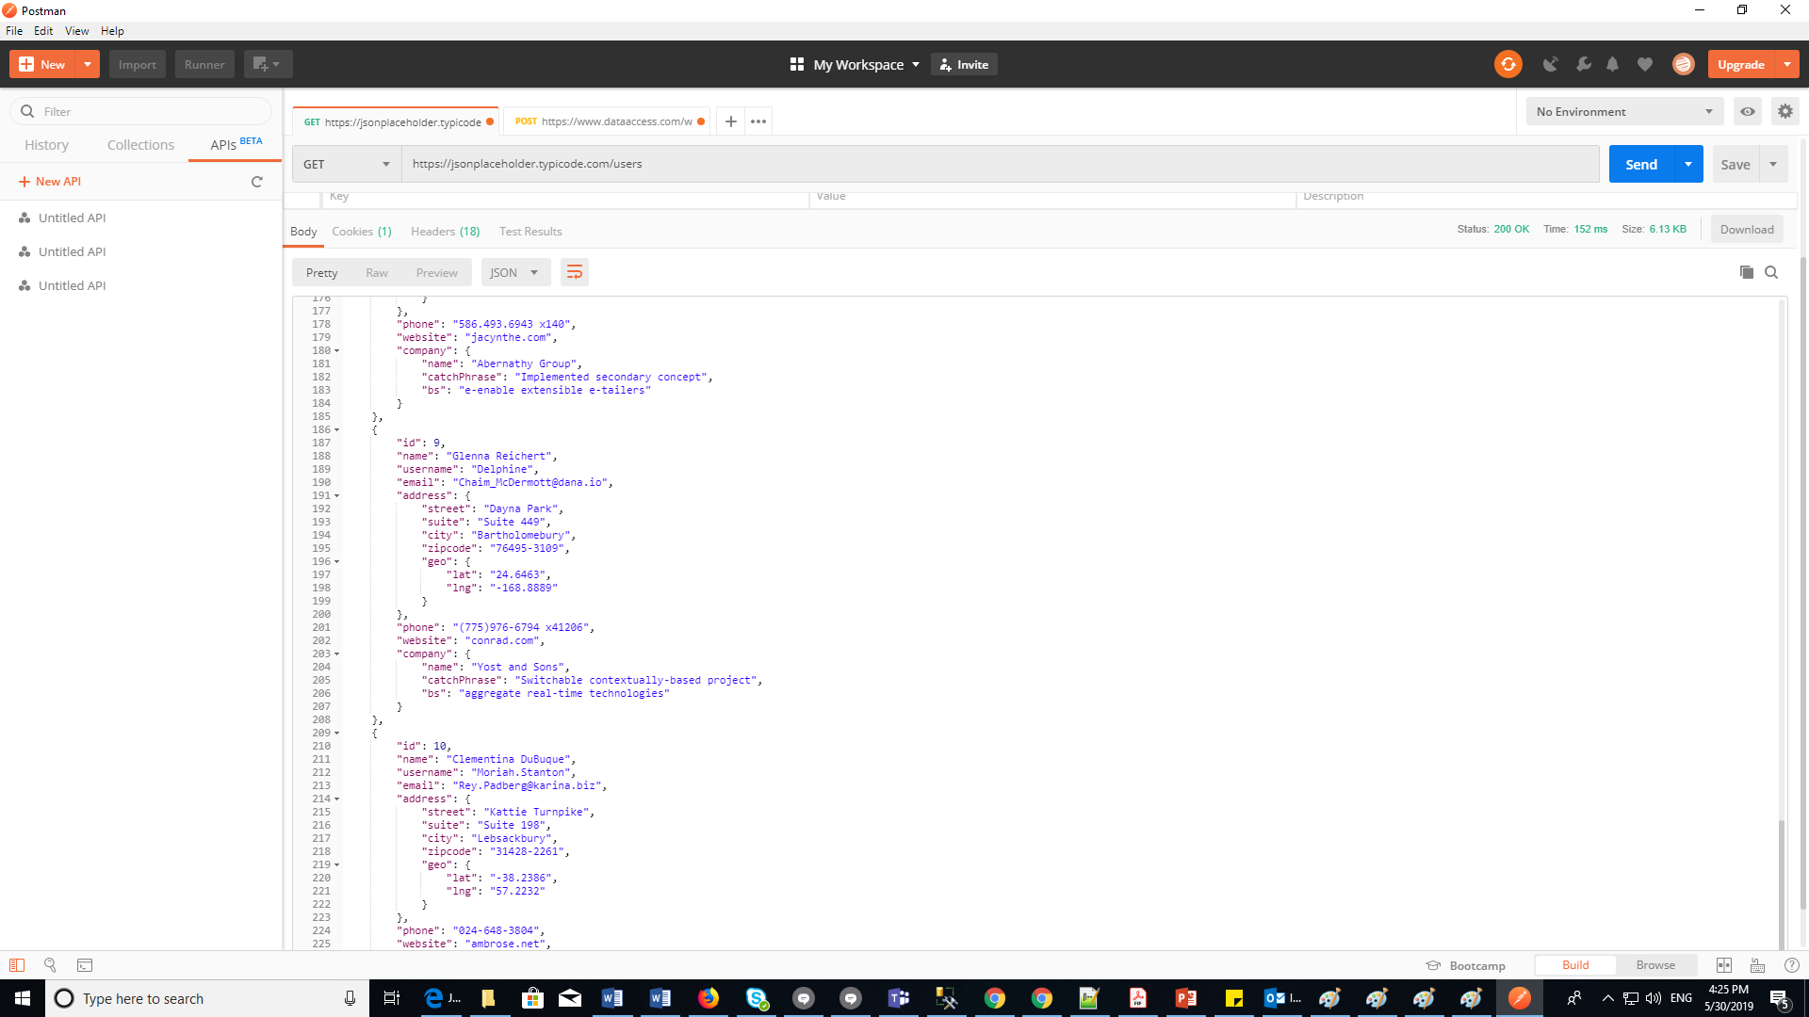

-------------------------------------------------------------------------------------------------------------------------------

1. **For each type of resource**:
2. **Get a specific resource data:**
3. verify the response code
4. ii. Verify the response body

Specific Resource data in posts: Response Code: 200 OK and Response body (Below screen shot):

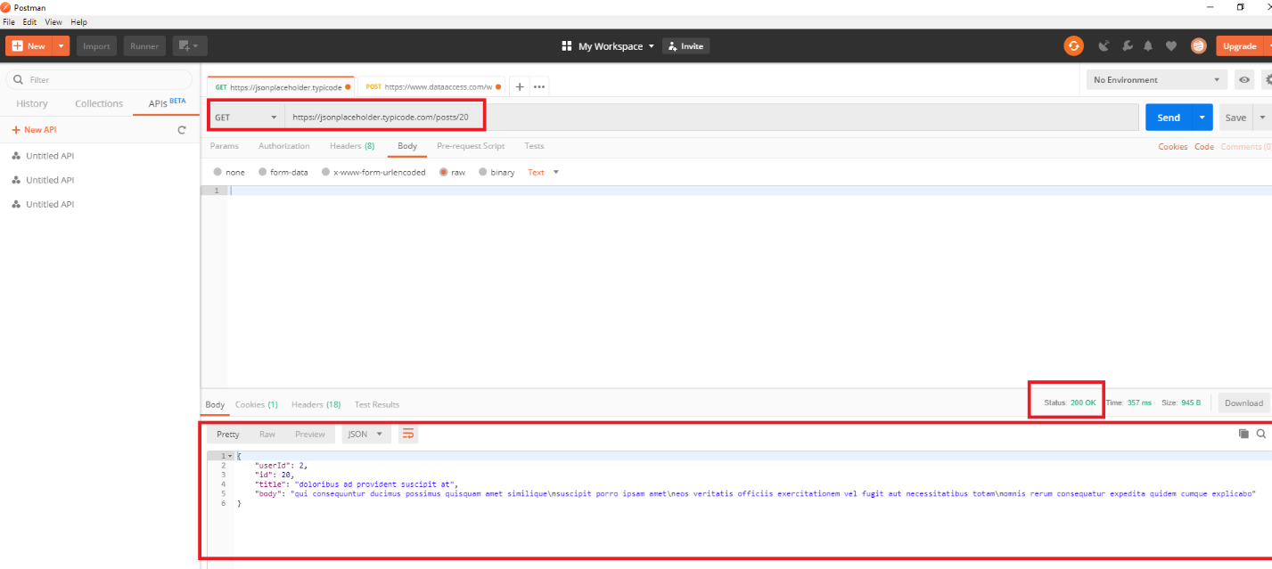

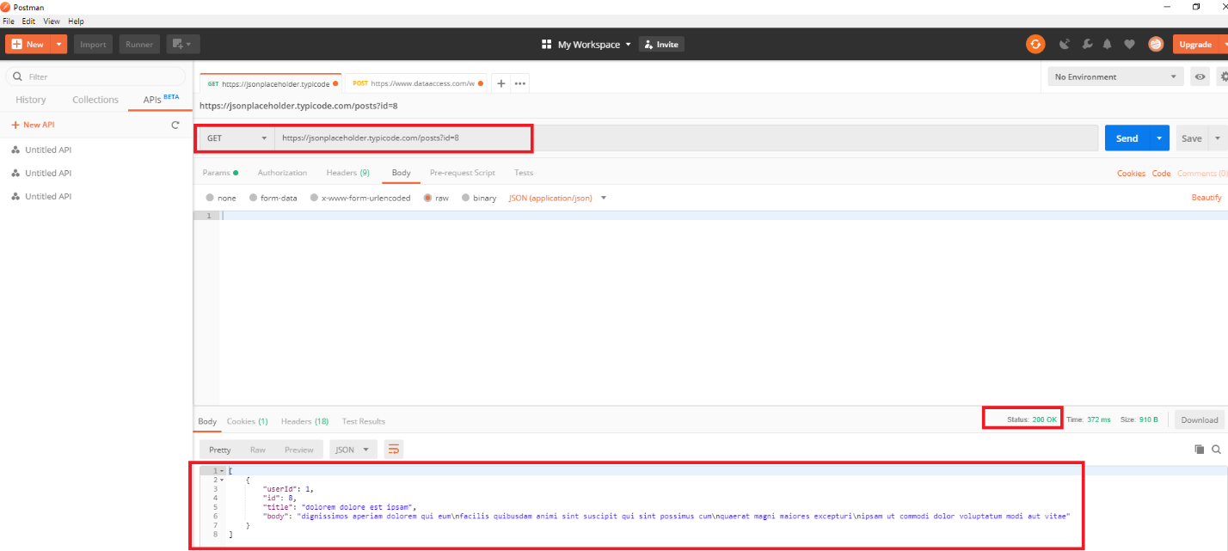

Specific Resource data in comments: Response Code: 200 OK and Response body (Below screen shot):

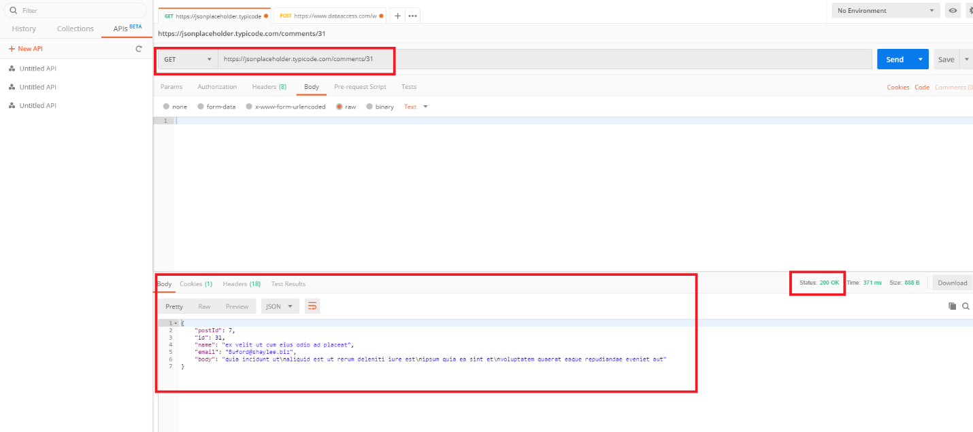

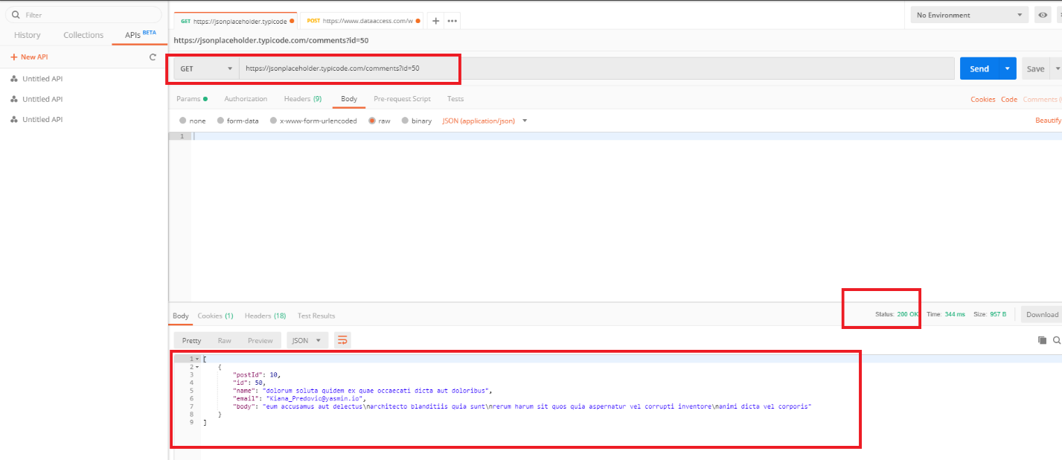

Specific Resource data in albums: Response Code: 200 OK and Response body (Below screen shot):

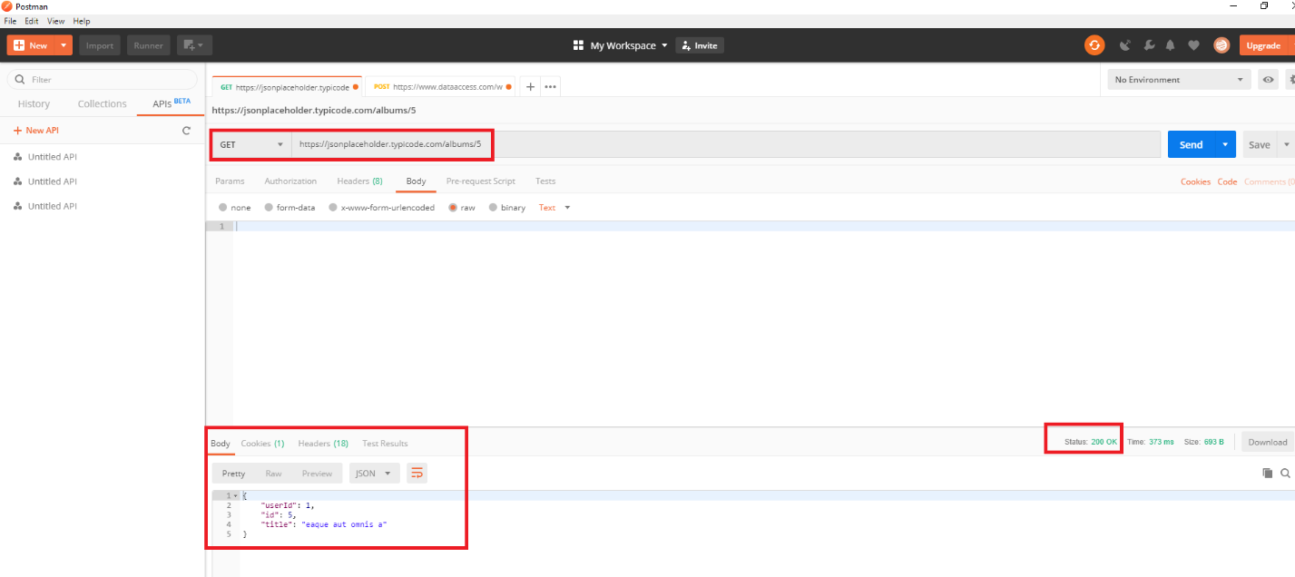

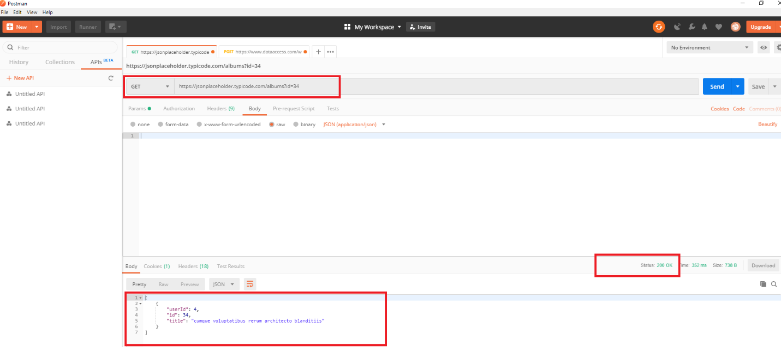

Specific Resource data in photos: Response Code: 200 OK and Response body (Below screen shot):

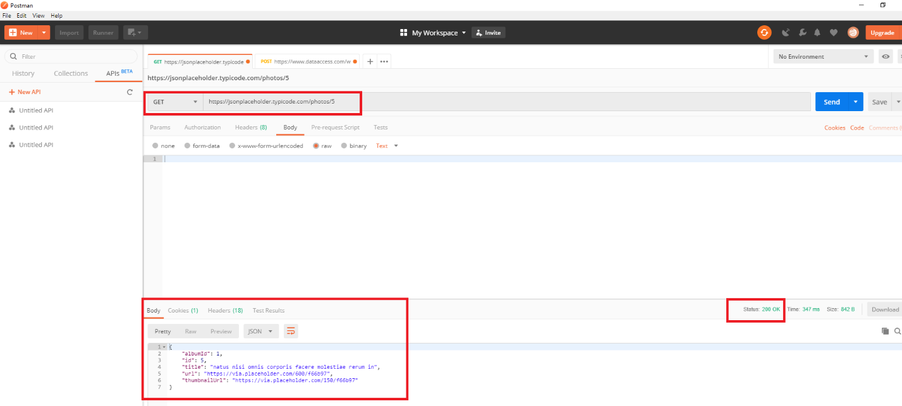

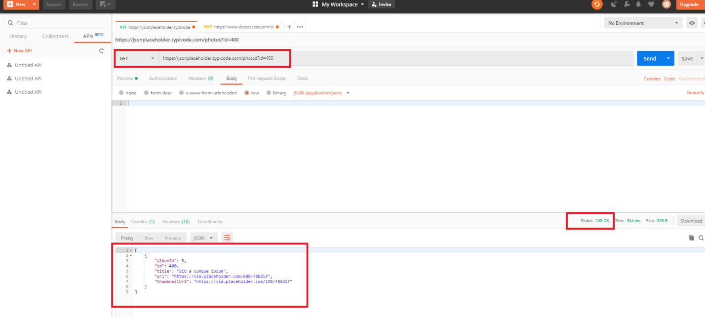

Specific Resource data in todos: Response Code: 200 OK and Response body (Below screen shot):

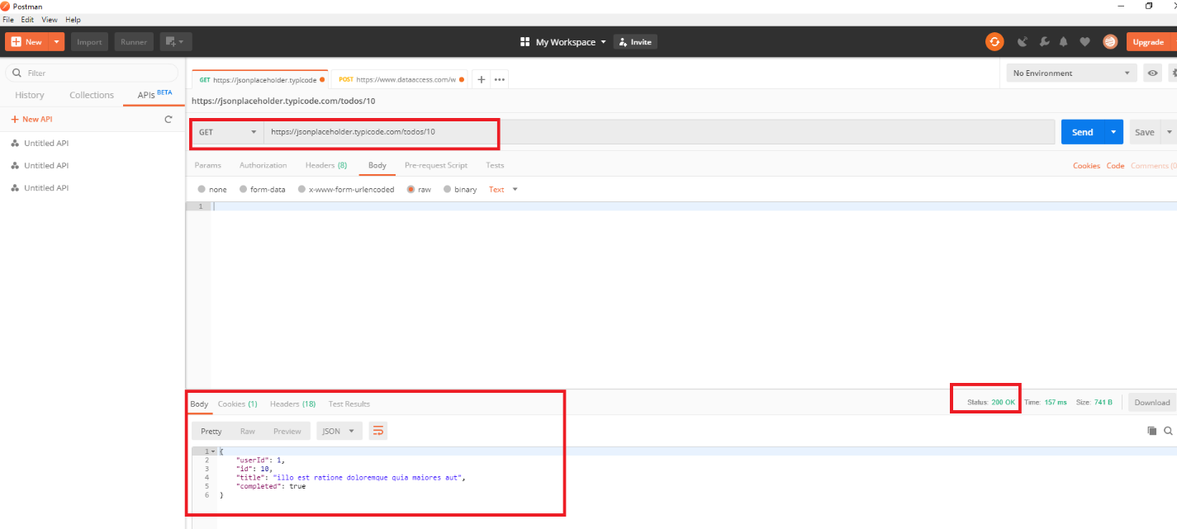

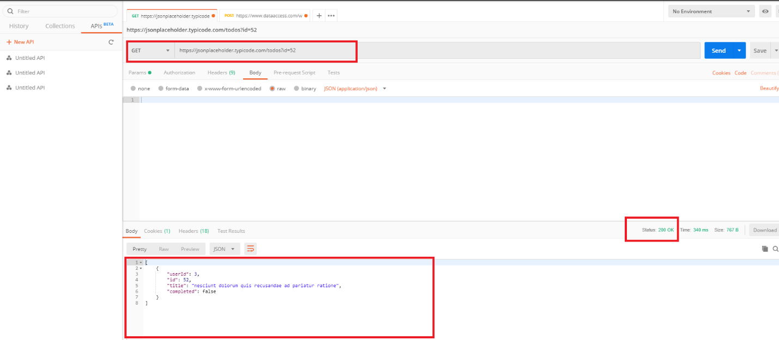

Specific Resource data in users: Response Code: 200 OK and Response body (Below screen shot):

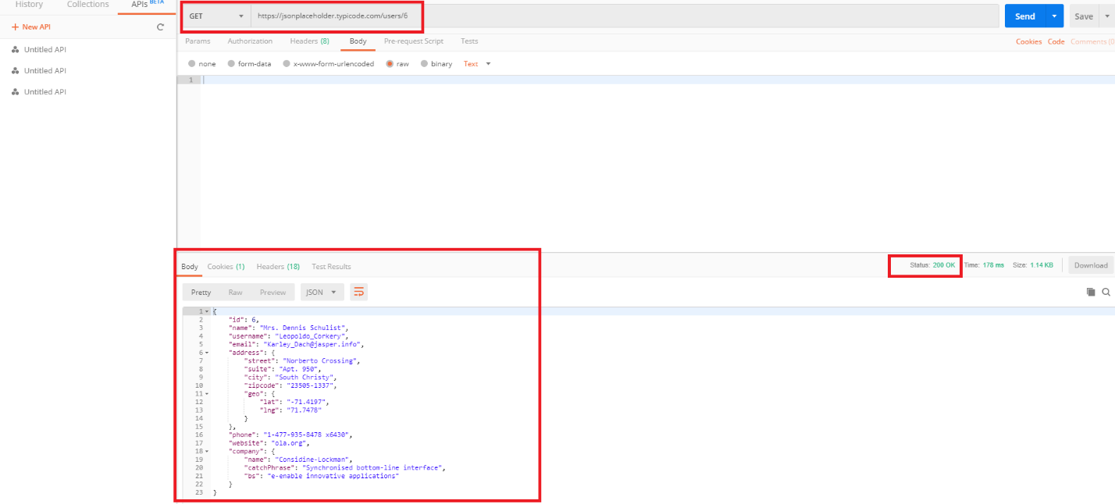

-----------------------------------------------------------------------------------------------------------------

1. **Modify a specific resource data:**
2. Verify the response code
3. Verify the response body
4. We have 100 posts in URL, I have created one post for modify

Response Code: 200 OK and Response body (Below screen shot):

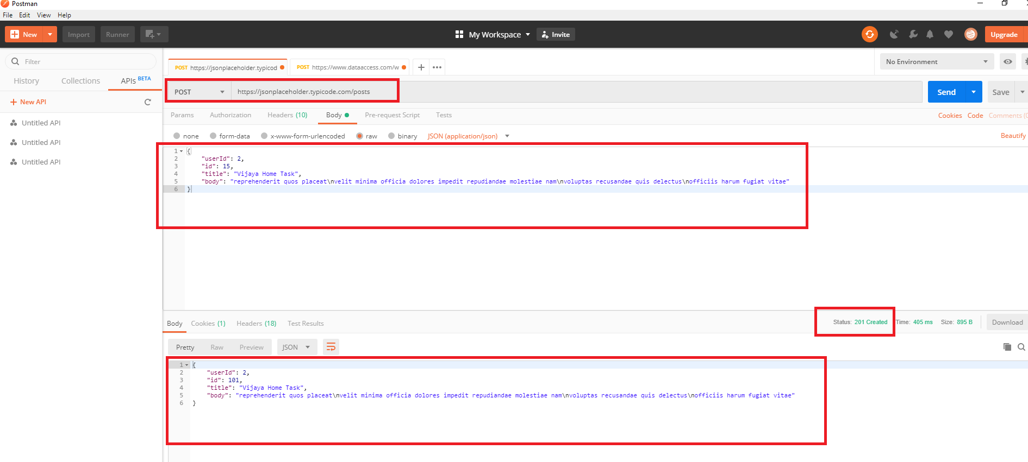

Bug: We have a bug while retrieving created data, but still it is displaying status code “200 OK”. Not getting updated data.

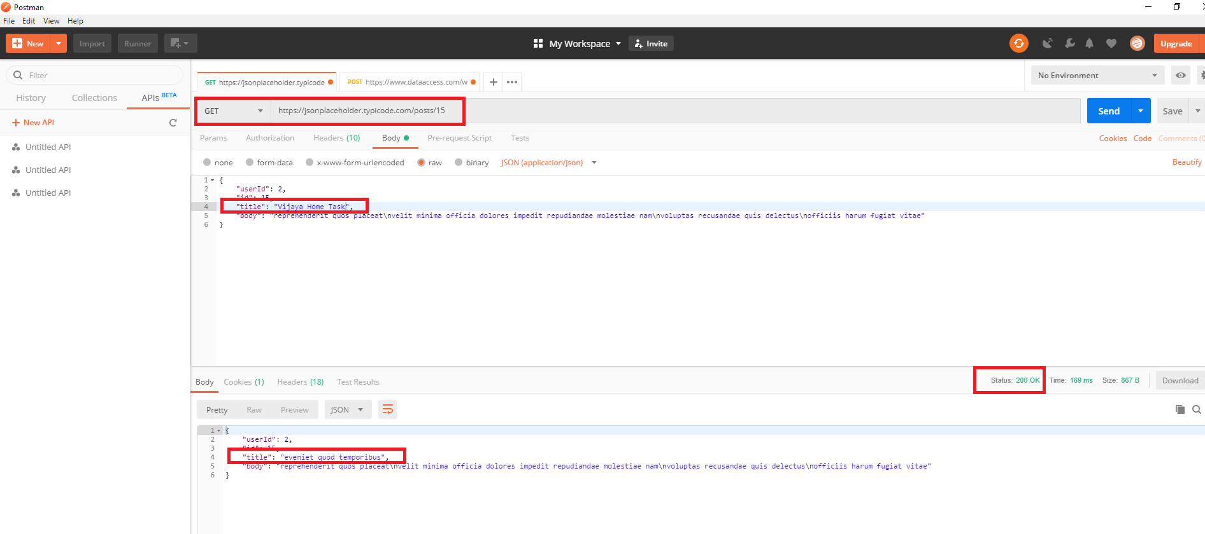

I have used PUT for update the postid:16:Body:

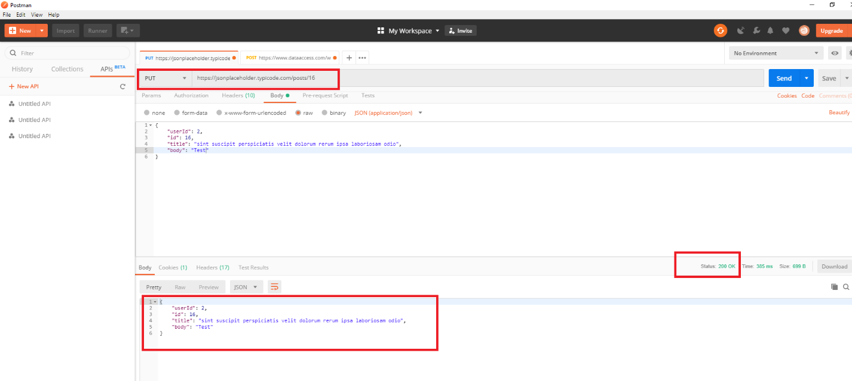

Bug: We have a bug while retrieving created data, but still it is displaying status code “200 OK”. Not getting updated data.

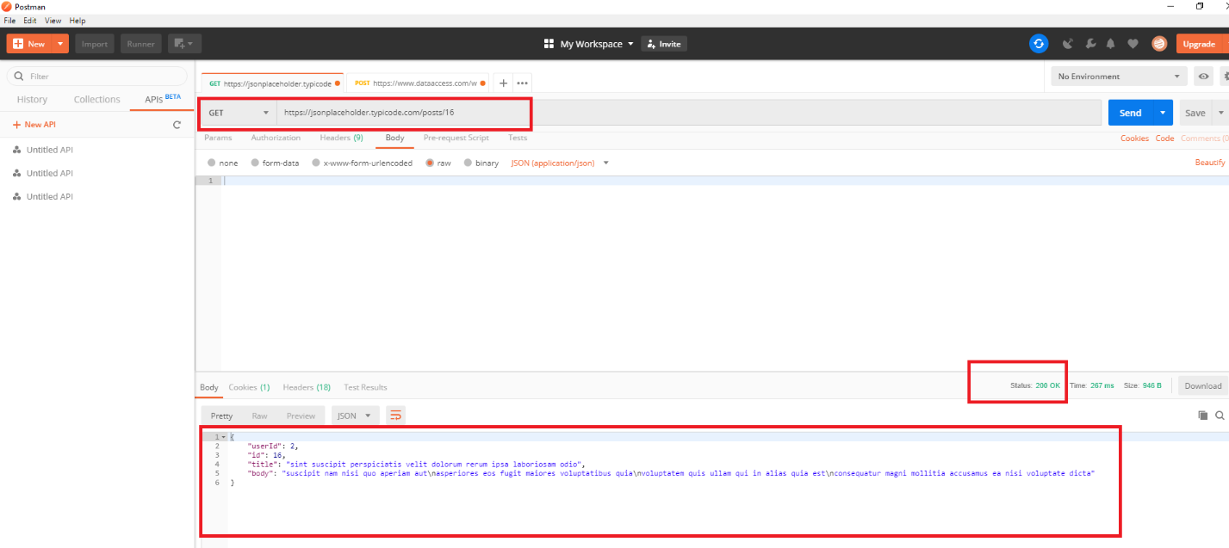

1. We have 500 comments in URL, I have updated comment

Response Code: 200 OK and Response body (Below screen shot):

I have updated “Postid:1” with “2” using PUT. Response Code: 200 OK and Response body (Below screen shot):

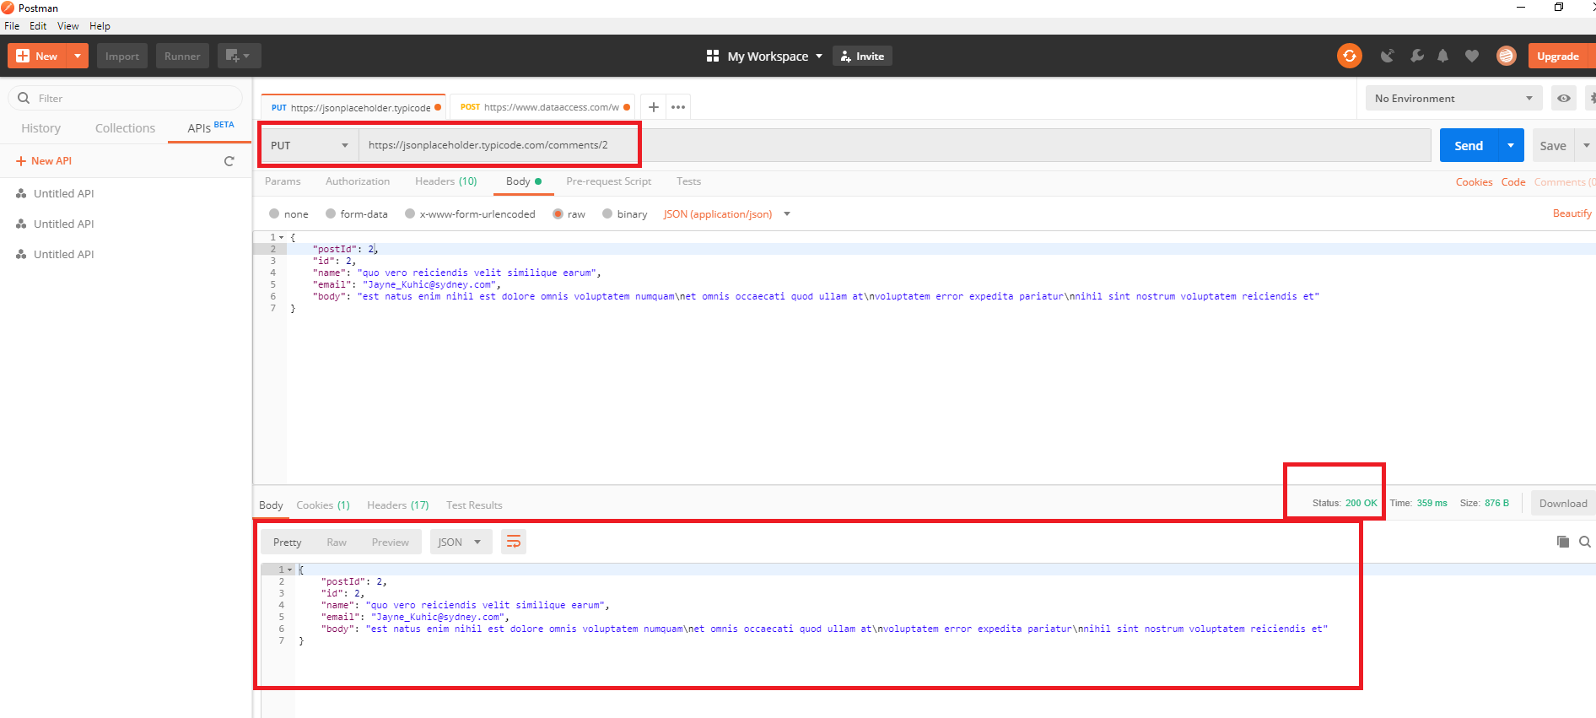

Bug: We have a bug while retrieving updated data, but still it is displaying status code “200 OK”. Not getting updated data.

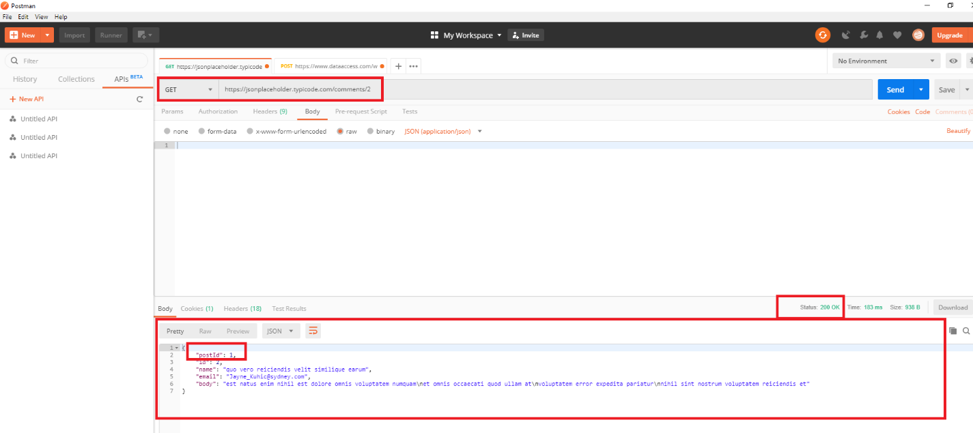

-----------------------------------------------------------------------------------------------------------------

1. We have 100 albums in URL, I have updated one album

Response Code: 200 OK and Response body (Below screen shot):

I have updated “userid:1” with “10” using PUT. Response Code: 200 OK and Response body (Below screen shot):

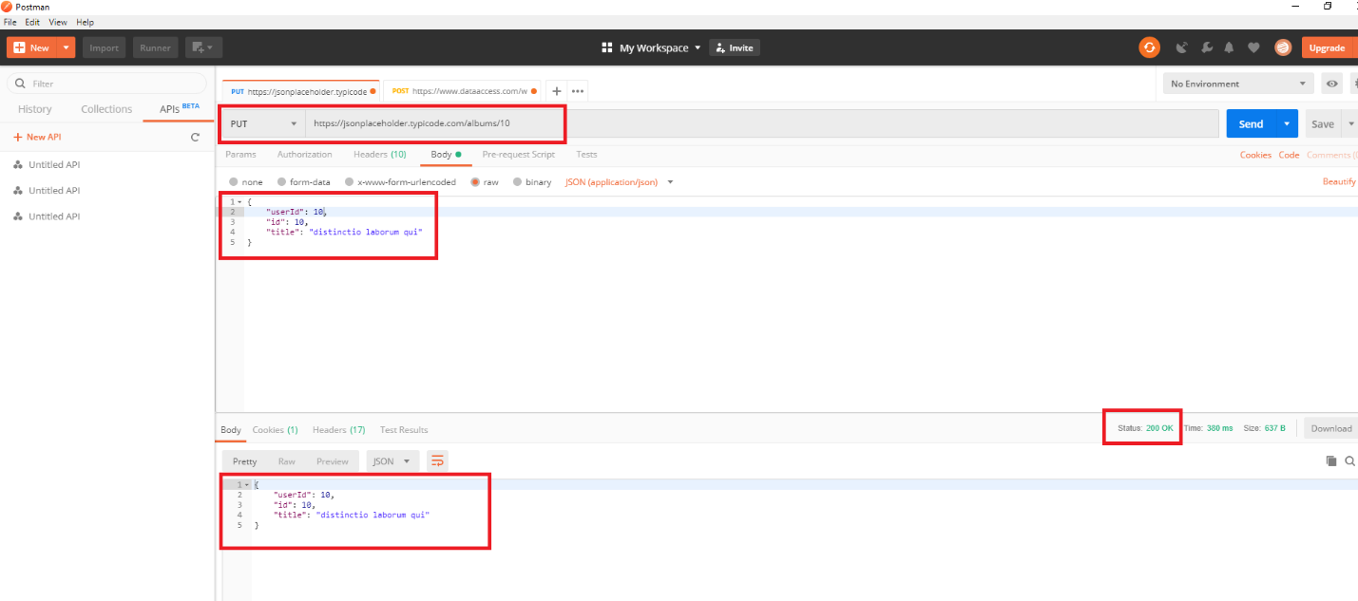

Bug: We have a bug while retrieving updated data, but still it is displaying status code “200 OK”. Not getting updated data.

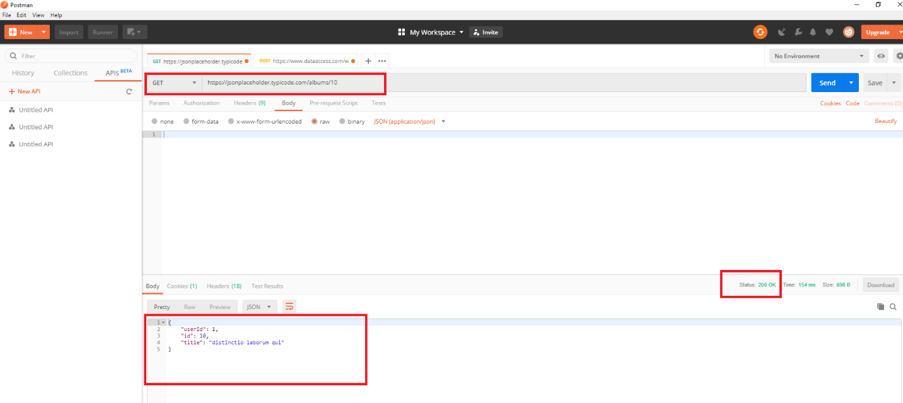

1. We have 5000 photos in URL, I have updated one photo Title

Response Code: 200 OK and Response body (Below screen shot):

I have updated “PhotoID-10-Title” with ”Vijaya Photo” using PUT. Response Code: 200 OK and Response body (Below screen shot):

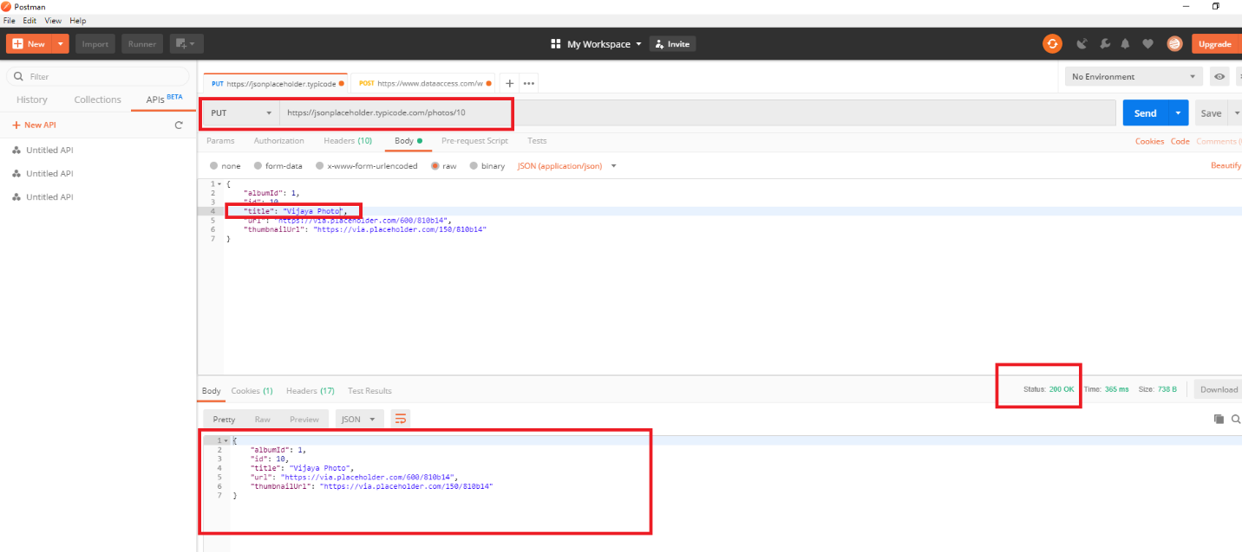

Bug: We have a bug while retrieving updated data, but still it is displaying status code “200 OK”. Not getting updated data.

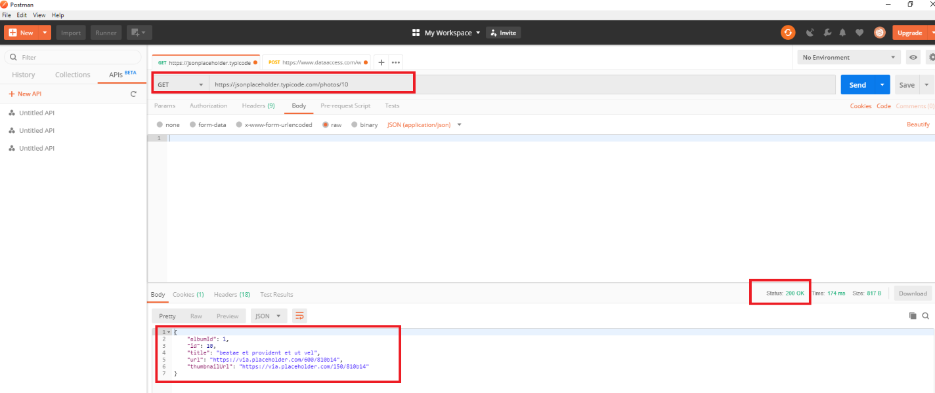

1. We have 200 todos in URL, I have updated one todo-userid

Response Code: 200 OK and Response body (Below screen shot):

I have updated “userid:1 with “10” using PUT. Response Code: 200 OK and Response body (Below screen shot):

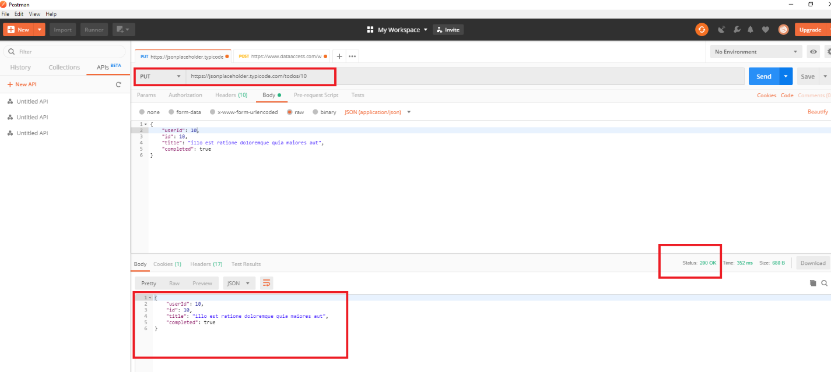

Bug: We have a bug while retrieving updated data, but still it is displaying status code “200 OK”. Not getting updated data.

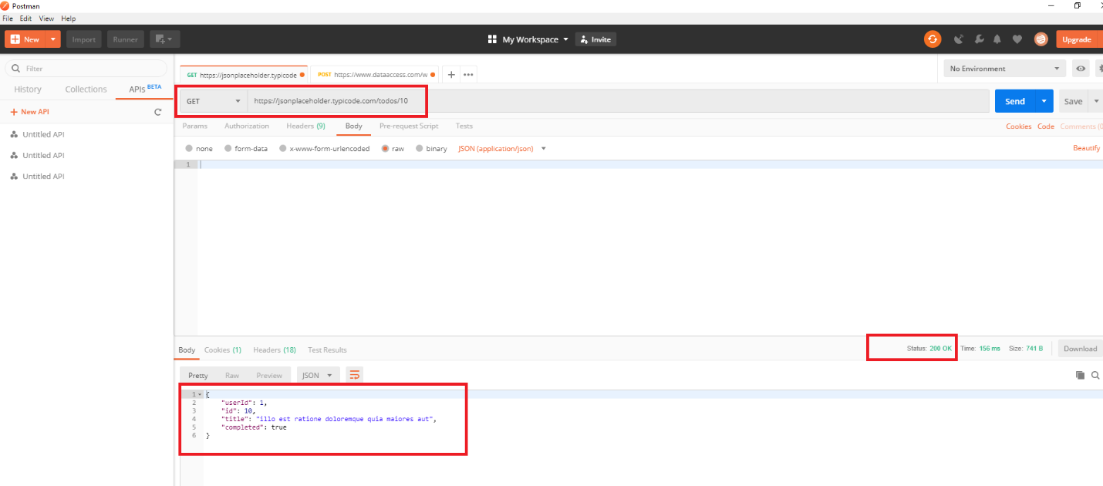

1. We have 10 users in URL, I have updated one user-5-phone number

Response Code: 200 OK and Response body (Below screen shot):

I have updated “user: 5: phone number with “8886009408” using PUT. Response Code: 200 OK and Response body (Below screen shot):

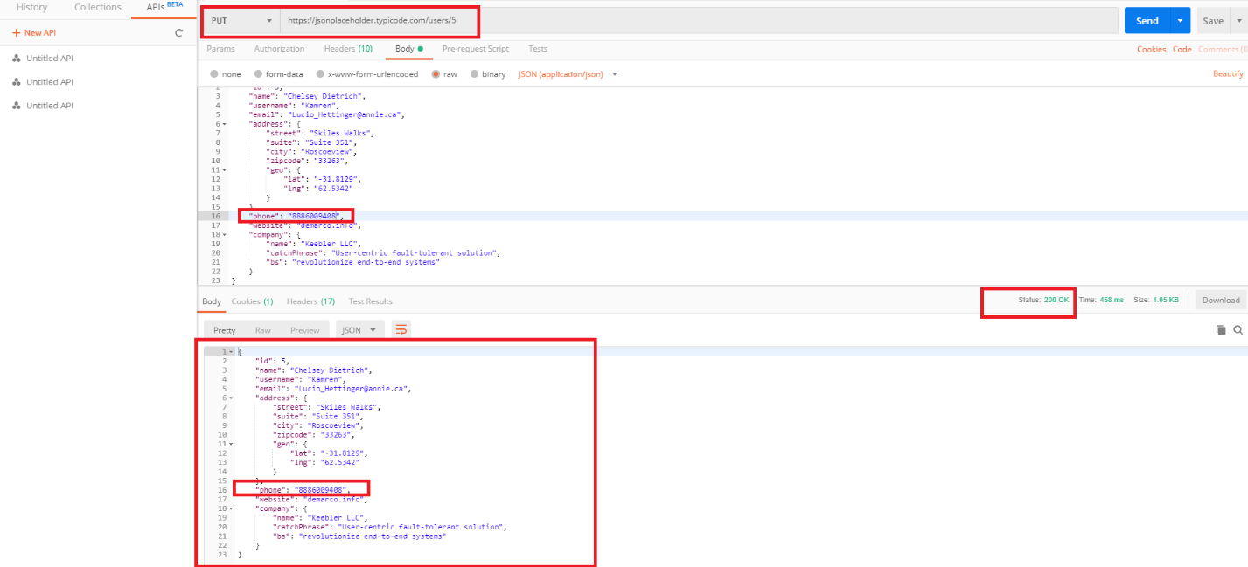

Bug: We have a bug while retrieving updated data, but still it is displaying status code “200 OK”. Not getting updated data.

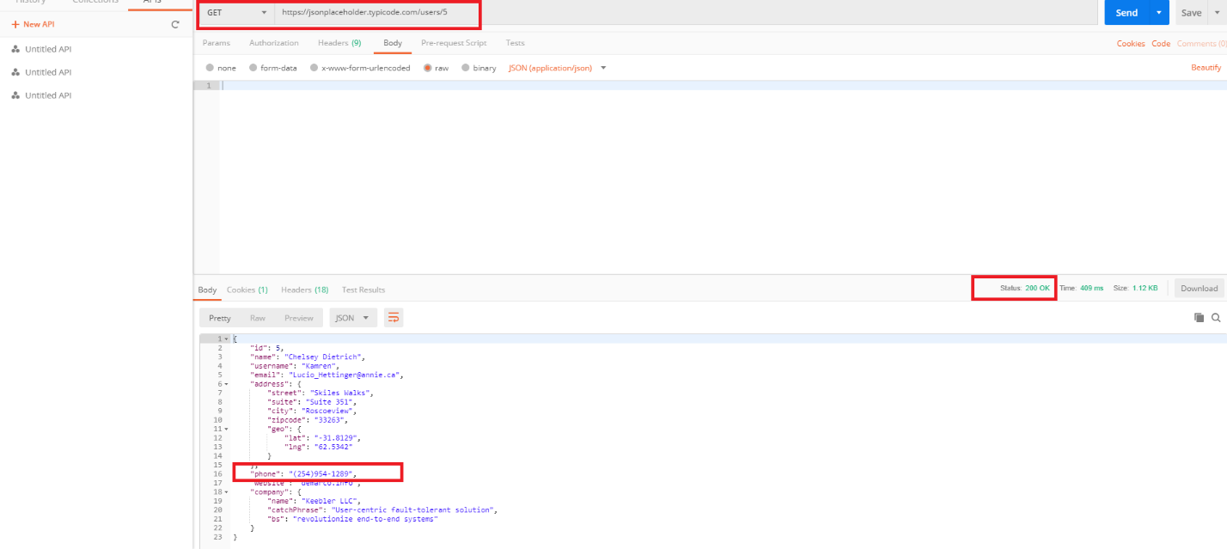

---------------------------------------------------------------------------------------------------------------------

1. **Delete a specific resource data:**
2. Verify the response code
3. Verify the response body
4. We have 100 posts in URL, I have deleted post:15

Response Code: 200 OK and Response body (Below screen shot): If post deleted successfully it should display in Response body, but here we are not getting any message. This is a BUG1.

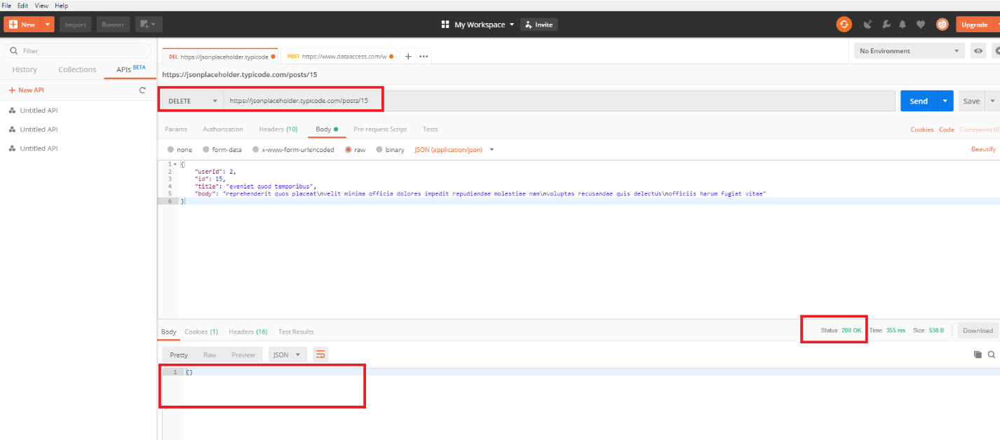

BUG2: If we hit the same request again it should display “The requested resource does not exist” message with status code: 404, but we are not getting any message in Response body.

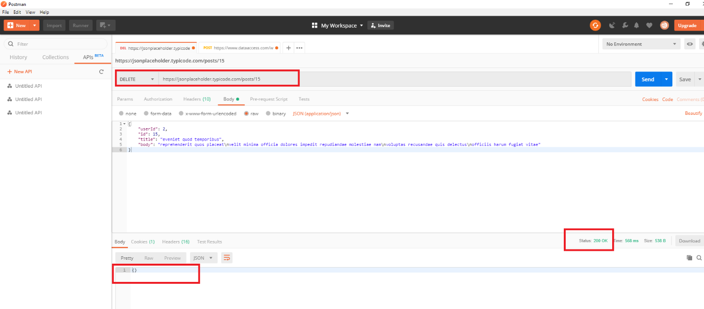

BUG3: Deleted resource is available and displayed in Response body while trying to fetch the same resource.

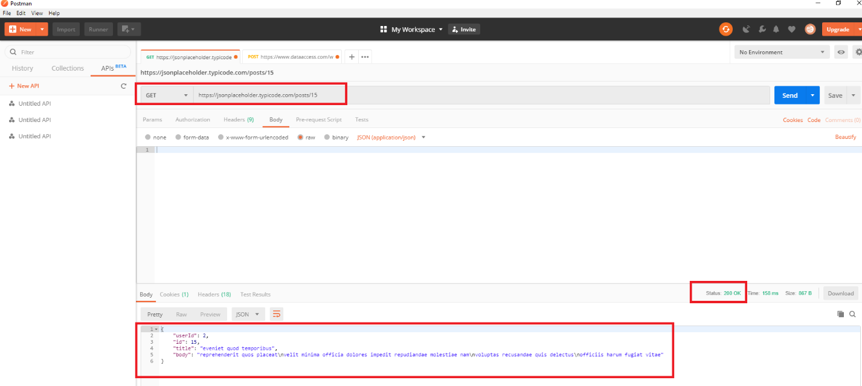

1. We have 500 comments in URL, I have deleted comment:51

Response Code: 200 OK and Response body (Below screen shot): If comment deleted successfully it should display in Response body, but here we are not getting any message. This is a BUG1.

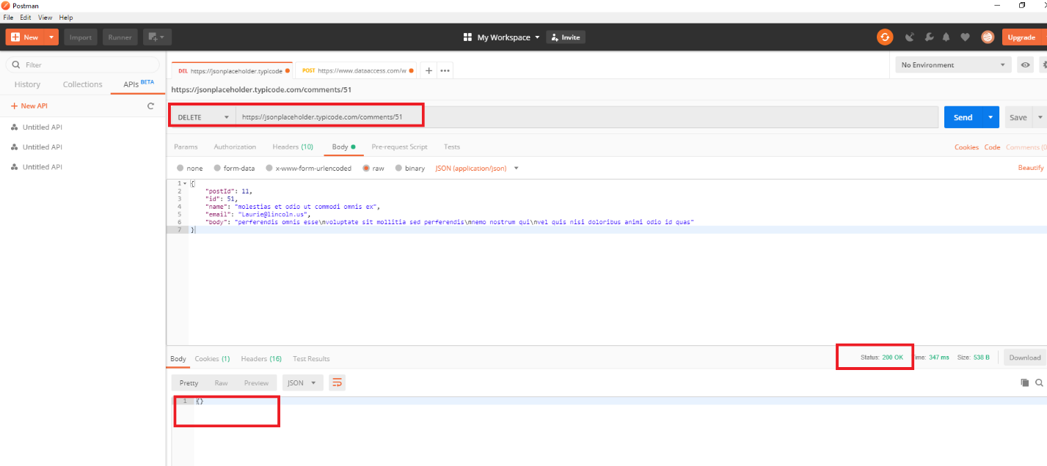

BUG2: If we hit the same request again it should display “The requested resource does not exist” message with status code: 404, but we are not getting any message in Response body.

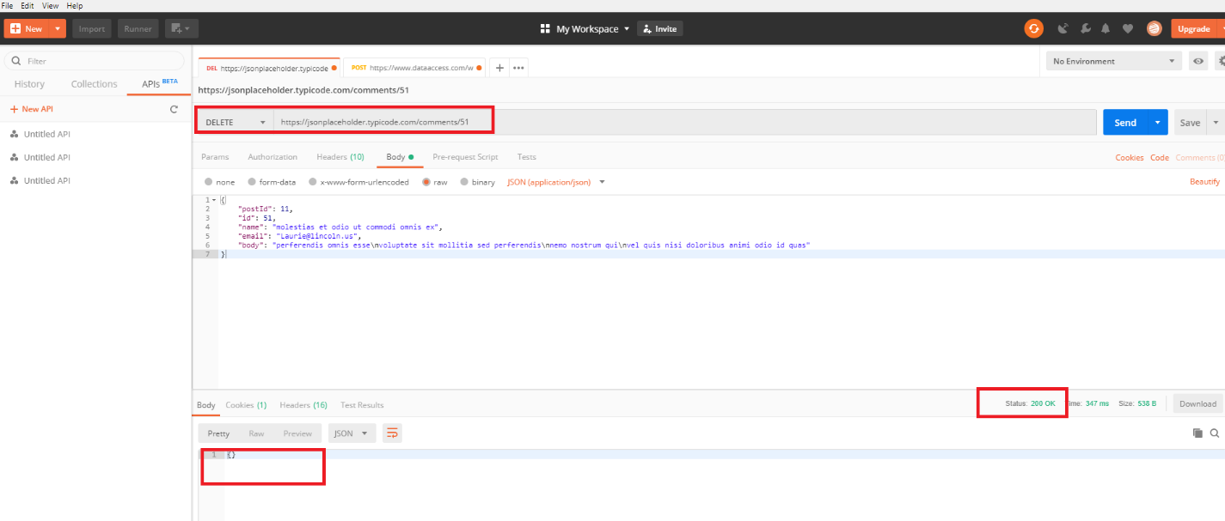

BUG3: Deleted resource is available and displayed in Response body while trying to fetch the same resource.

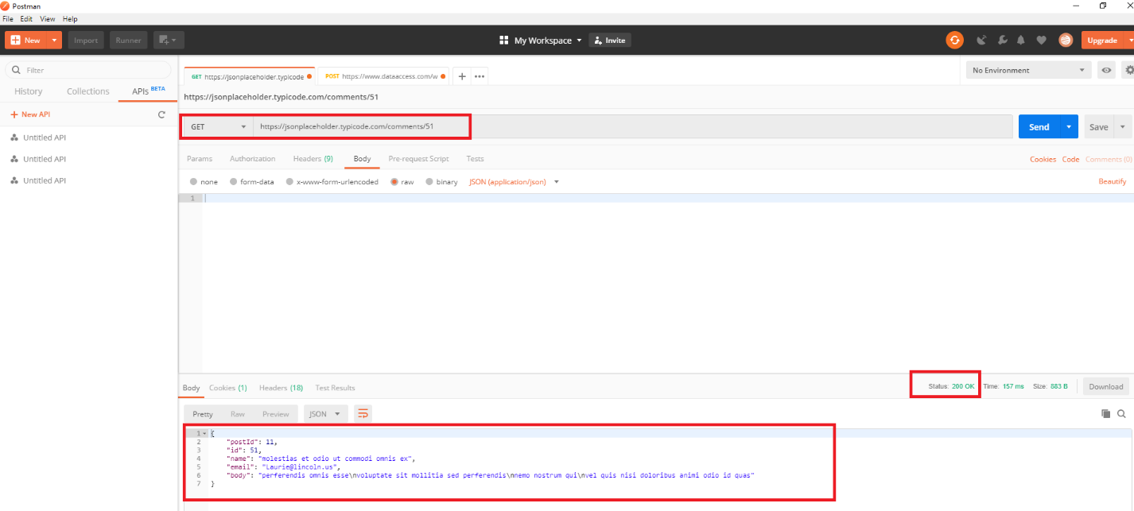

1. We have 100 albums in URL, I have deleted album:20

Response Code: 200 OK and Response body (Below screen shot): If album deleted successfully it should display in Response body, but here we are not getting any message. This is a BUG1.

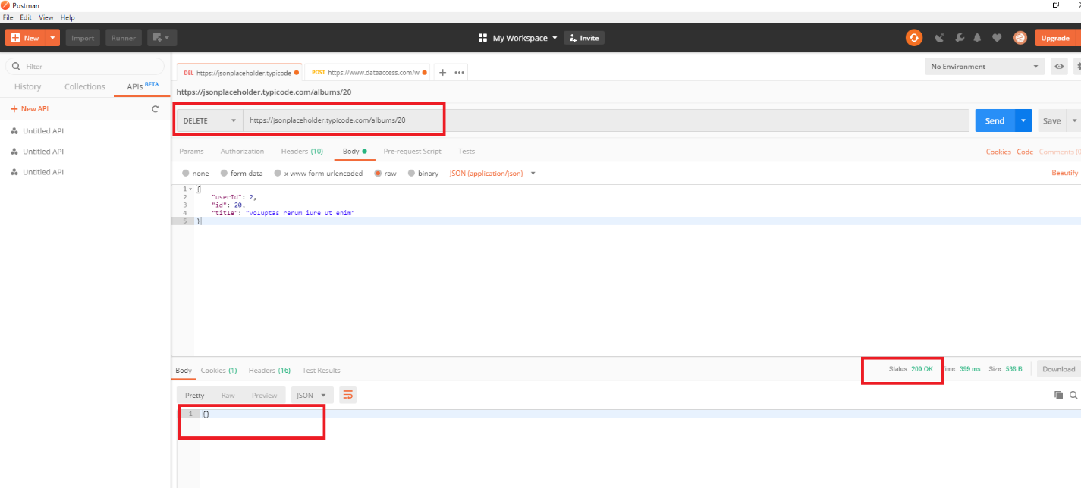

BUG2: If we hit the same request again it should display “The requested resource does not exist” message with status code: 404, but we are not getting any message in Response body.

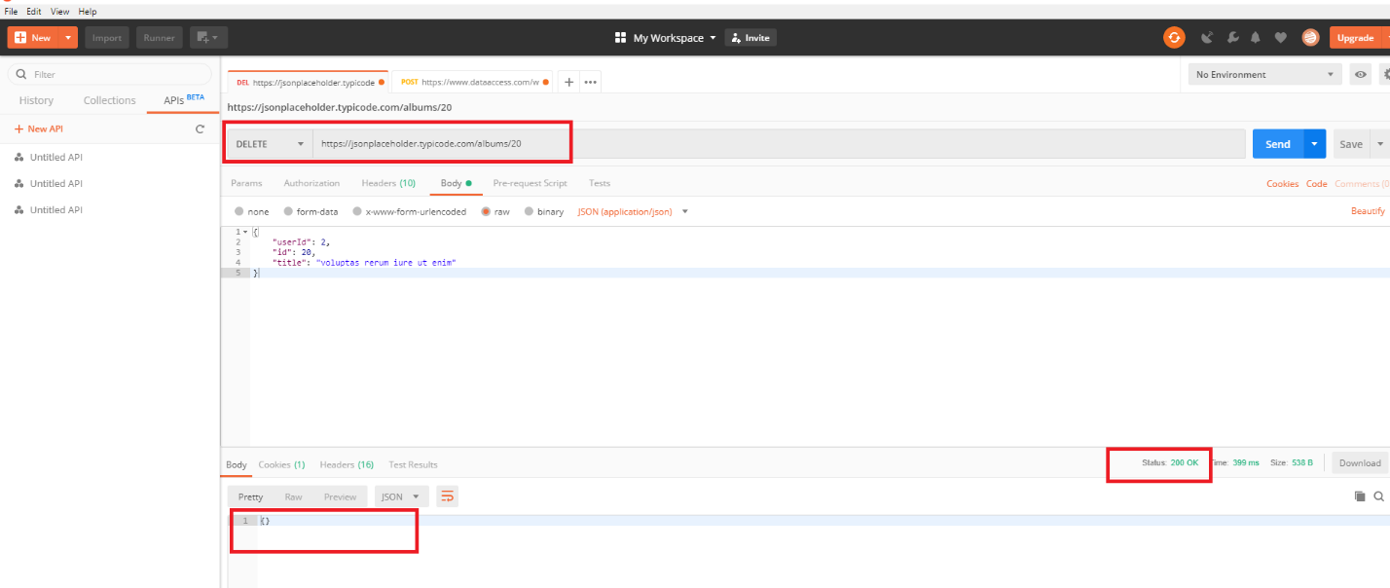

BUG3: Deleted resource is available and displayed in Response body while trying to fetch the same resource.

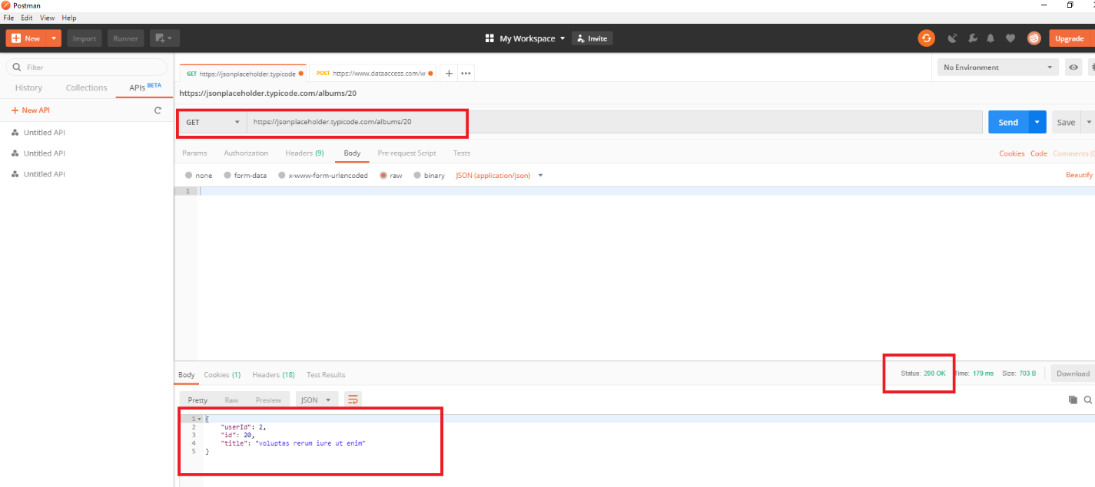

1. We have 5000 photos in URL, I have deleted photo:3012

Response Code: 200 OK and Response body (Below screen shot): If photo deleted successfully it should display in Response body, but here we are not getting any message. This is a BUG1.

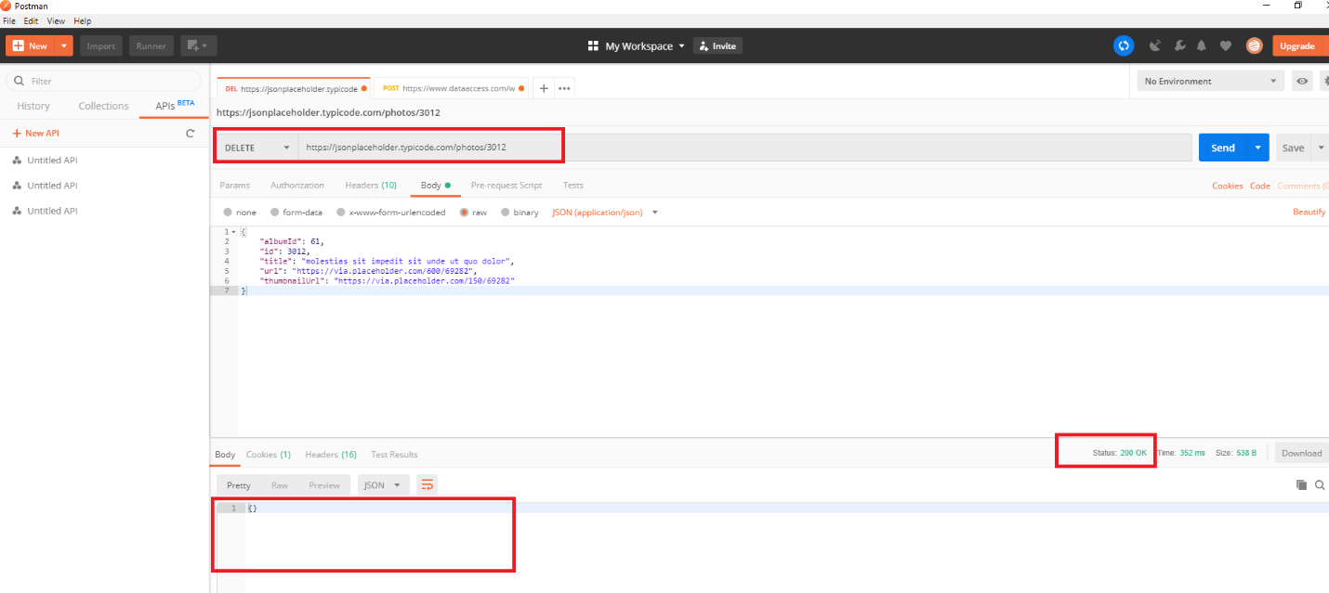

BUG2: If we hit the same request again it should display “The requested resource does not exist” message with status code: 404, but we are not getting any message in Response body.

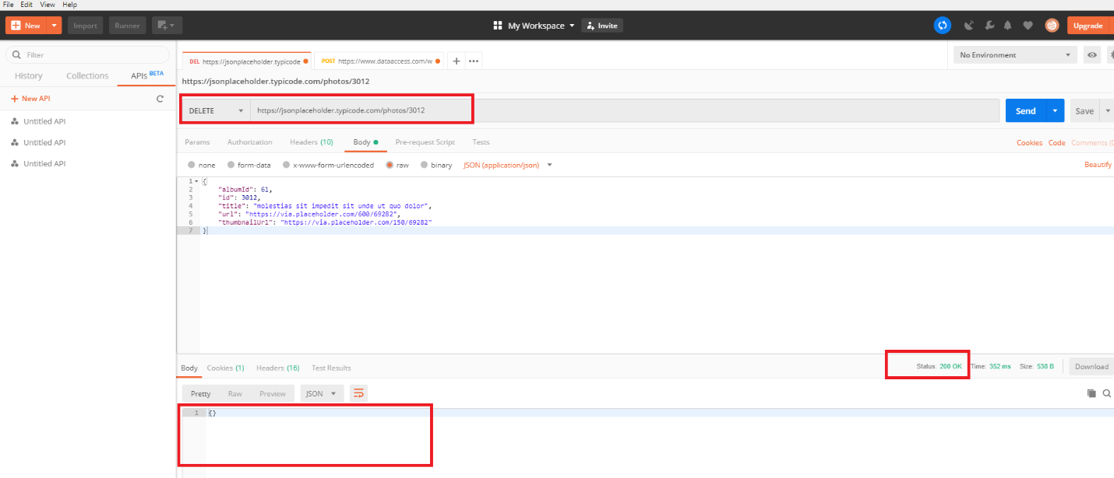

BUG3: Deleted resource is available and displayed in Response body while trying to fetch the same resource.

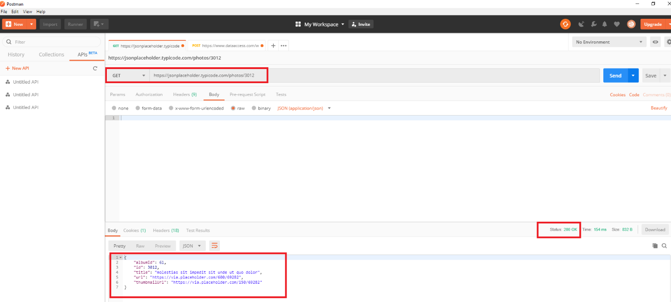

1. We have 200 todos in URL, I have deleted todo:109

Response Code: 200 OK and Response body (Below screen shot): If todo deleted successfully it should display in Response body, but here we are not getting any message. This is a BUG1.

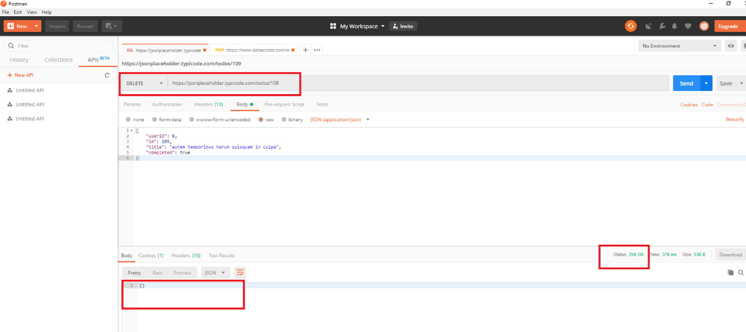

BUG2: If we hit the same request again it should display “The requested resource does not exist” message with status code: 404, but we are not getting any message in Response body.

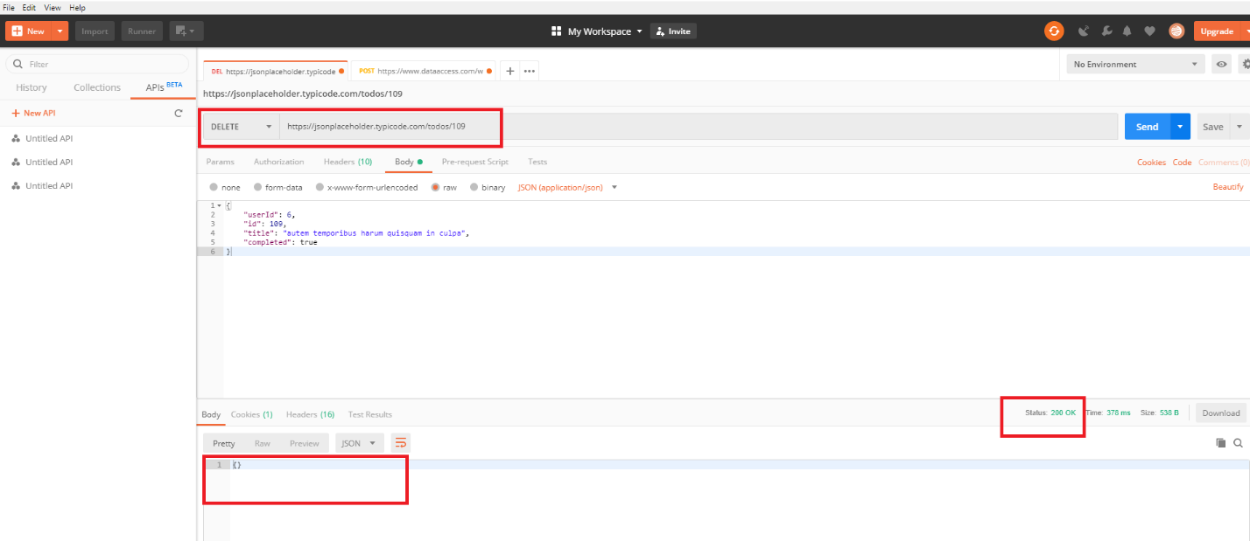

BUG3: Deleted resource is available and displayed in Response body while trying to fetch the same resource.

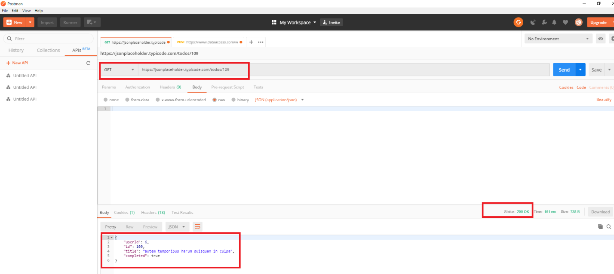

1. We have 10 users in URL, I have deleted user:6

Response Code: 200 OK and Response body (Below screen shot): If user deleted successfully it should display in Response body, but here we are not getting any message. This is a BUG1.

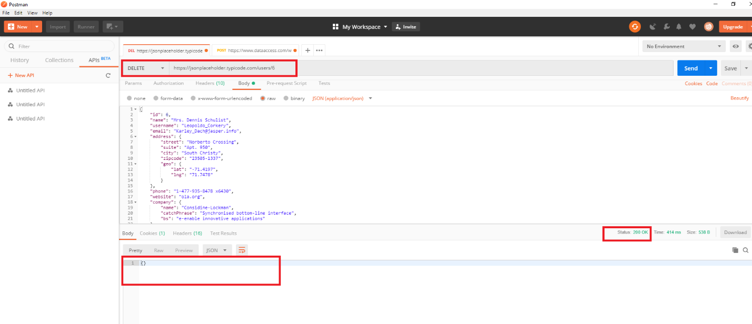

BUG2: If we hit the same request again it should display “The requested resource does not exist” message with status code: 404, but we are not getting any message in Response body.

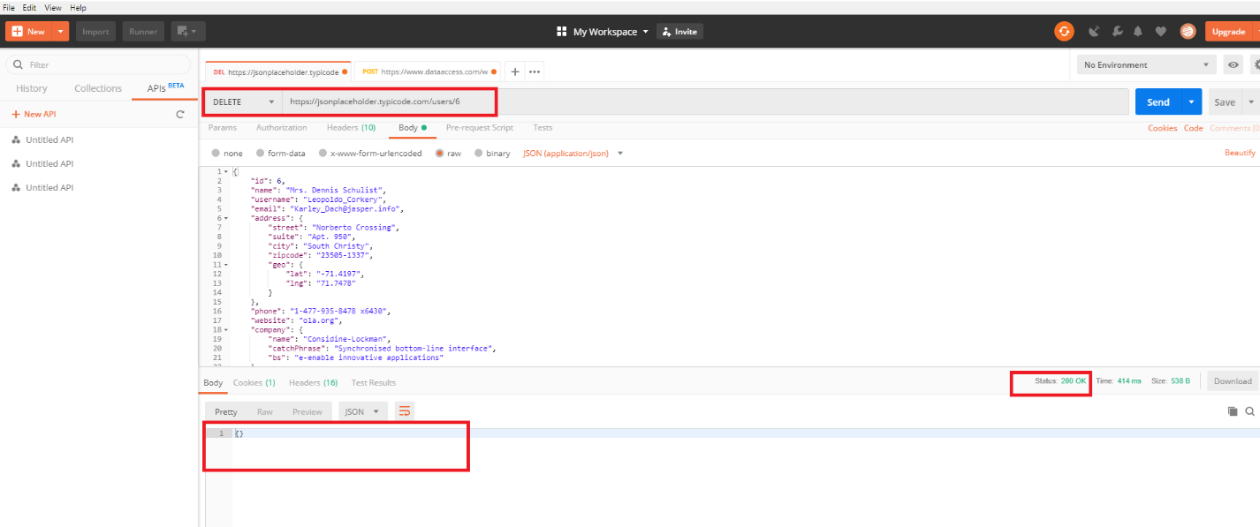

BUG3: Deleted resource is available and displayed in Response body while trying to fetch the same resource.

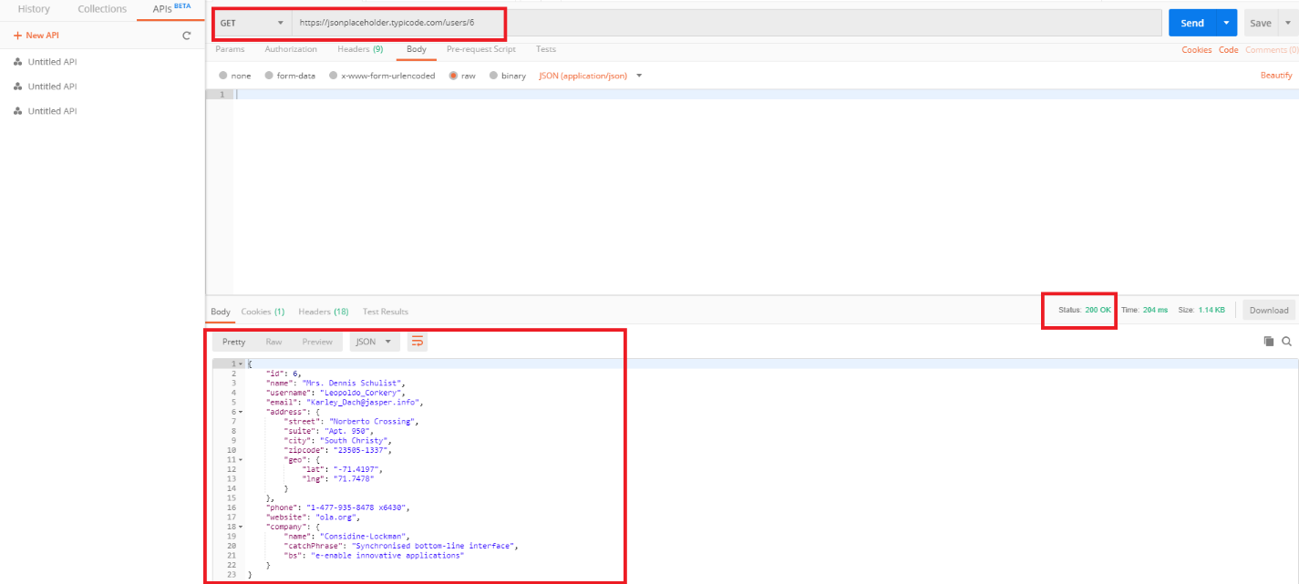

-----------------------------------------------------------------------------------------------------------------

1. **Create your own resource data:**
2. Verify the response code
3. Verify the response body
4. Posts: 100: I have created 101 post. Response Code: 201 created and Response body (Below screen shot):

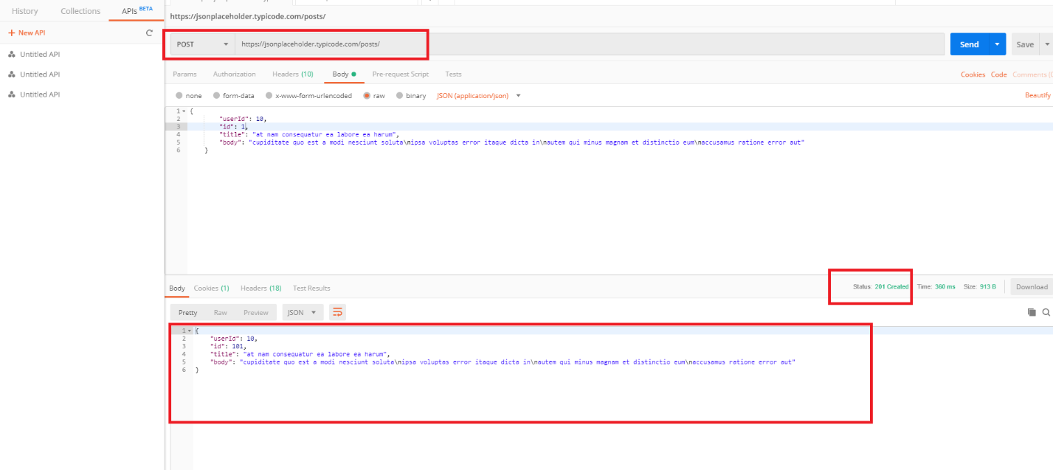

BUG1: If post created successfully it should display but, while trying to get the created post we got “404 Not Found” status and below response body.

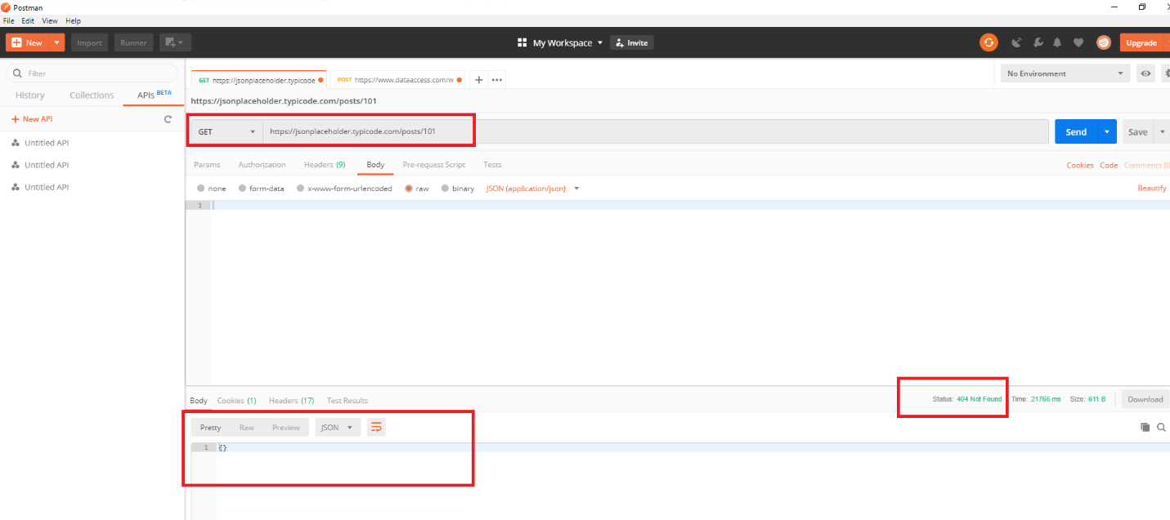

1. Comments: 500: I have created 501 comment resource. Response Code: 201 created and Response body (Below screen shot):

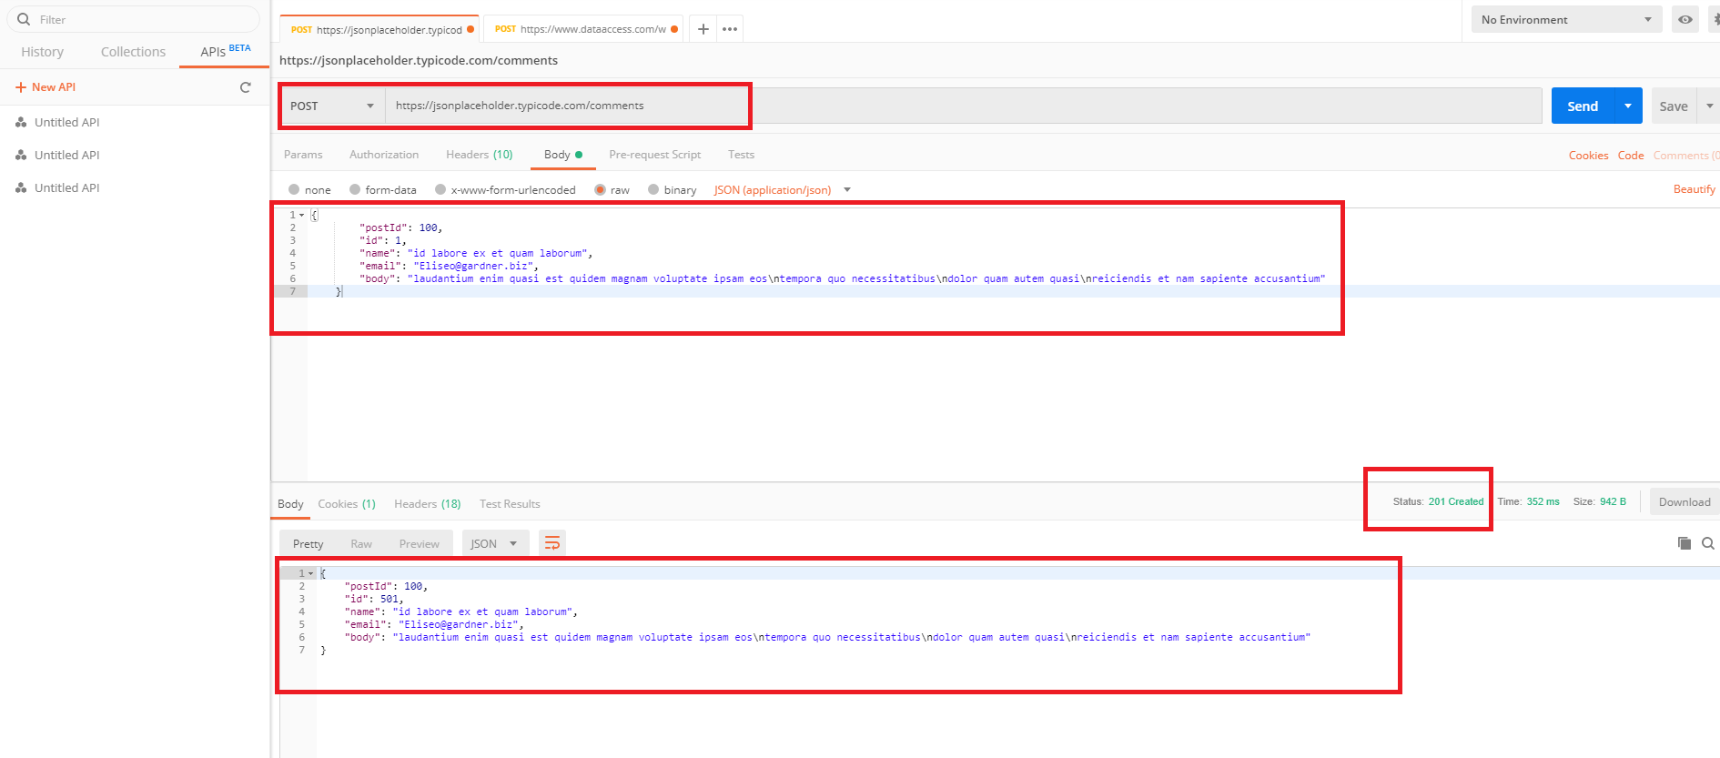

BUG1: If comment created successfully it should display but, while trying to get the created comment we got “404 Not Found” status and below response body.

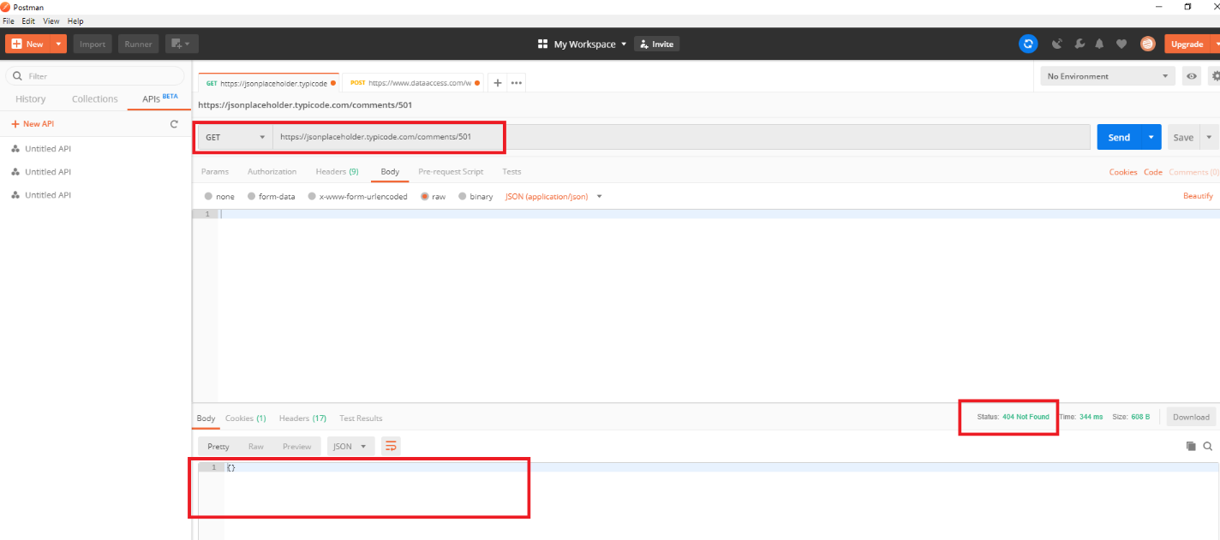

1. Albums: 100: I have created 101 album resource. Response Code: 201 created and Response body (Below screen shot):

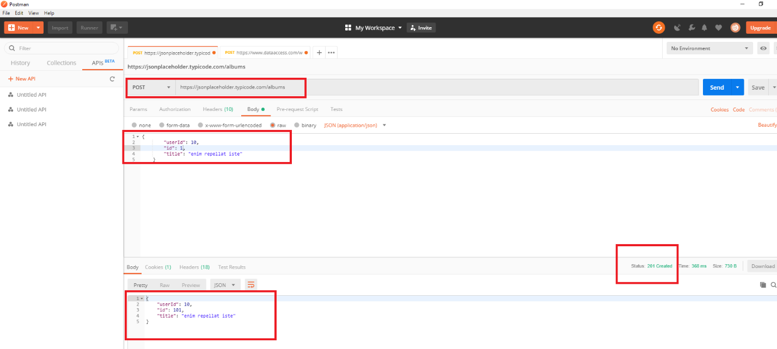

BUG1: If album created successfully it should display but, while trying to get the created album we got “404 Not Found” status and below response body.

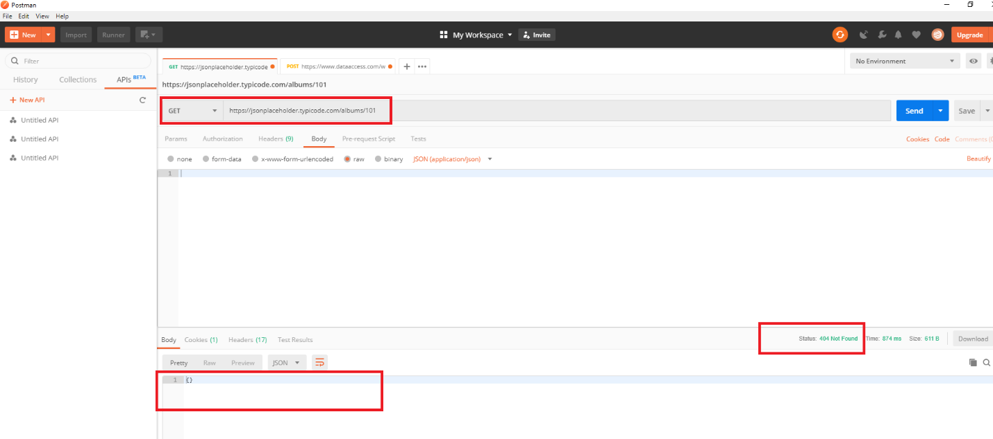

1. Photos: 5000: I have created 5001 photo resource. Response Code: 201 created and Response body (Below screen shot):

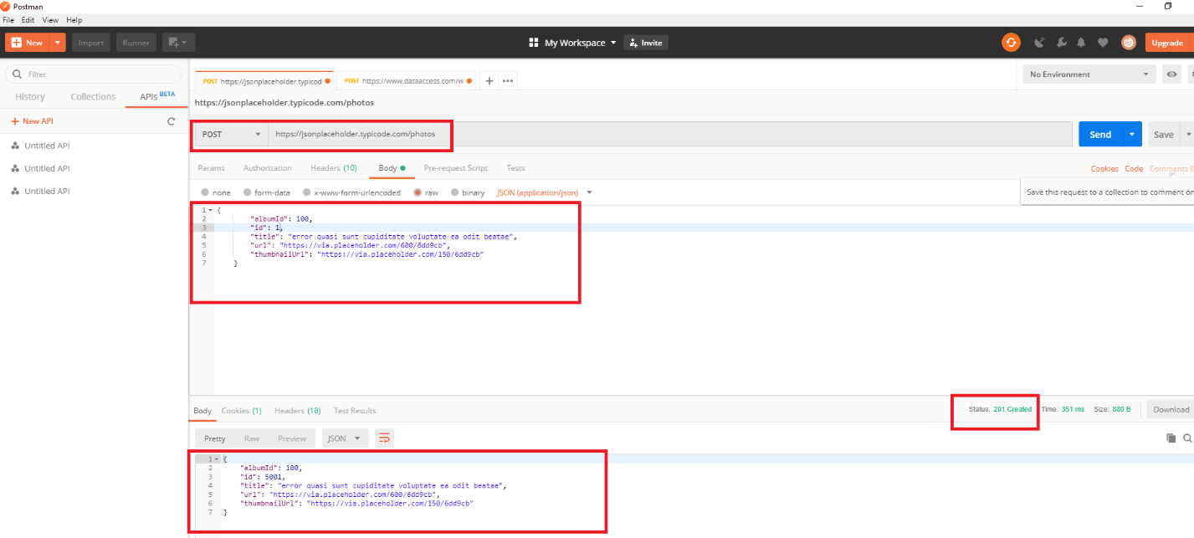

BUG1: If photo created successfully it should display but, while trying to get the created photo we got “404 Not Found” status and below response body.

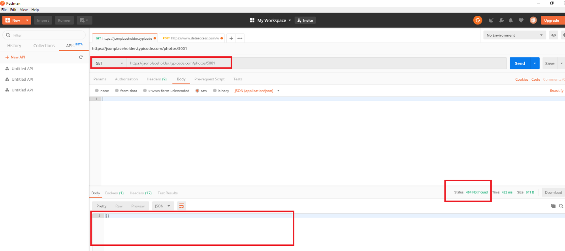

1. Todos: 200: I have created 201 todos resource. Response Code: 201 created and Response body (Below screen shot):

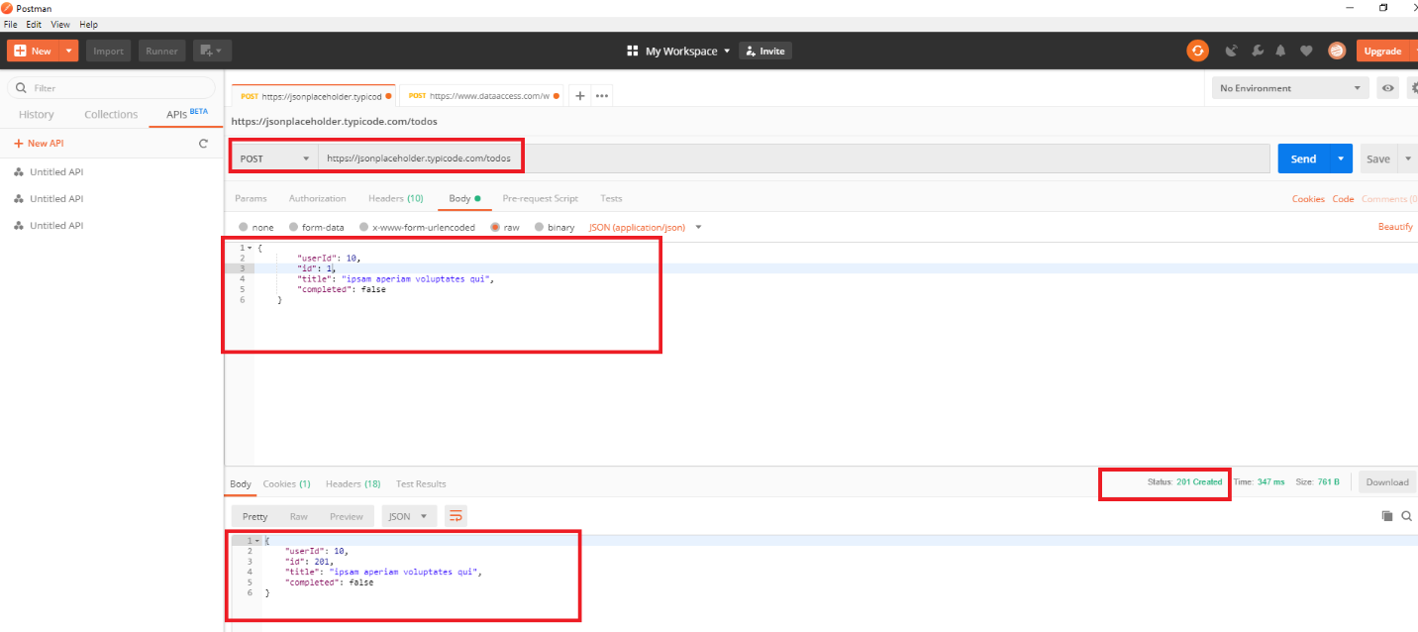

BUG1: If todos created successfully it should display but, while trying to get the created todos we got “404 Not Found” status and below response body.

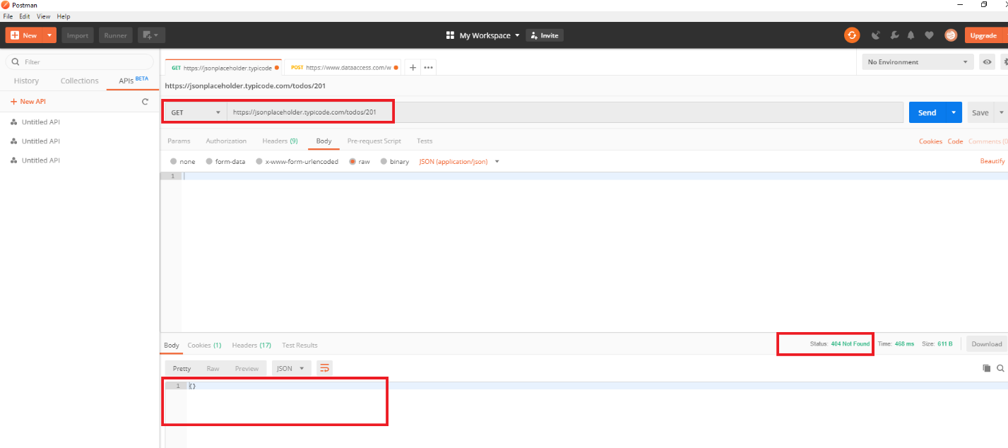

1. Users: 10: I have created 11 user resource. Response Code: 201 created and Response body (Below screen shot):

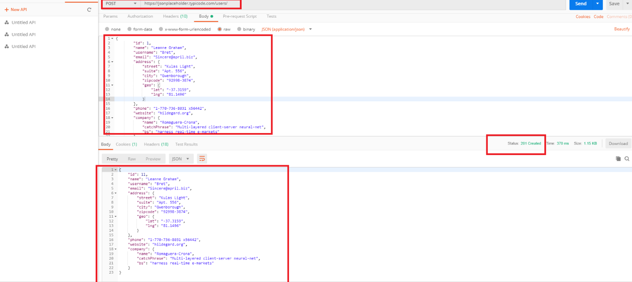

BUG1: If user created successfully it should display, but while trying to get the created user we got “404 Not Found” status and below response body.

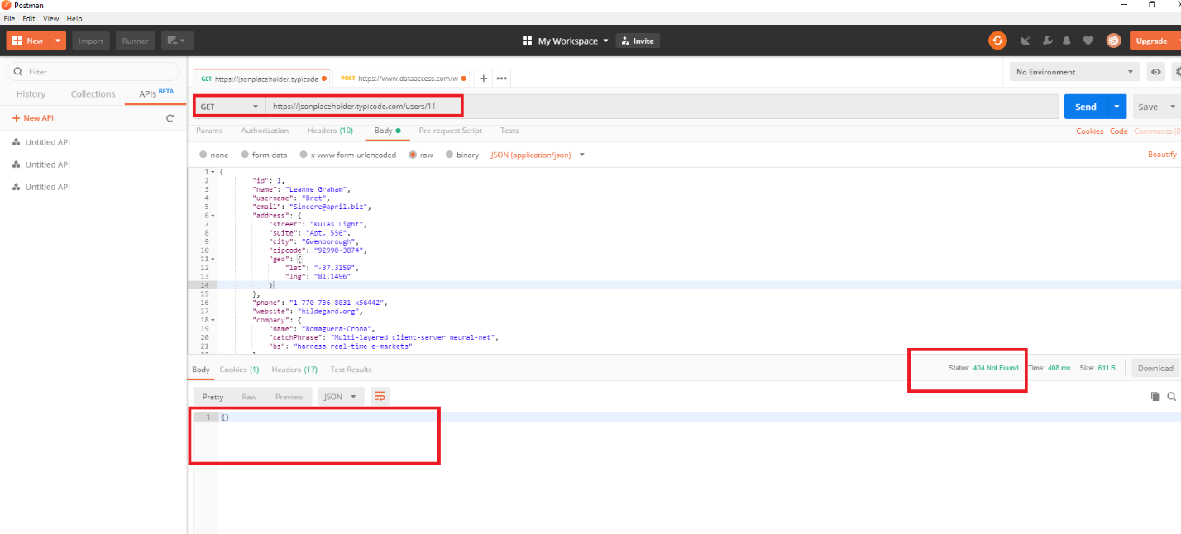

BUG(Exist in 6 Resources): By default it is taking next serial number for all resources, if we try to update the resource with user given numbers (See below screen shot). This is exist in all 6 resources.

